1.Create a P-T-S VPN and attach a VM to it

Select any vm

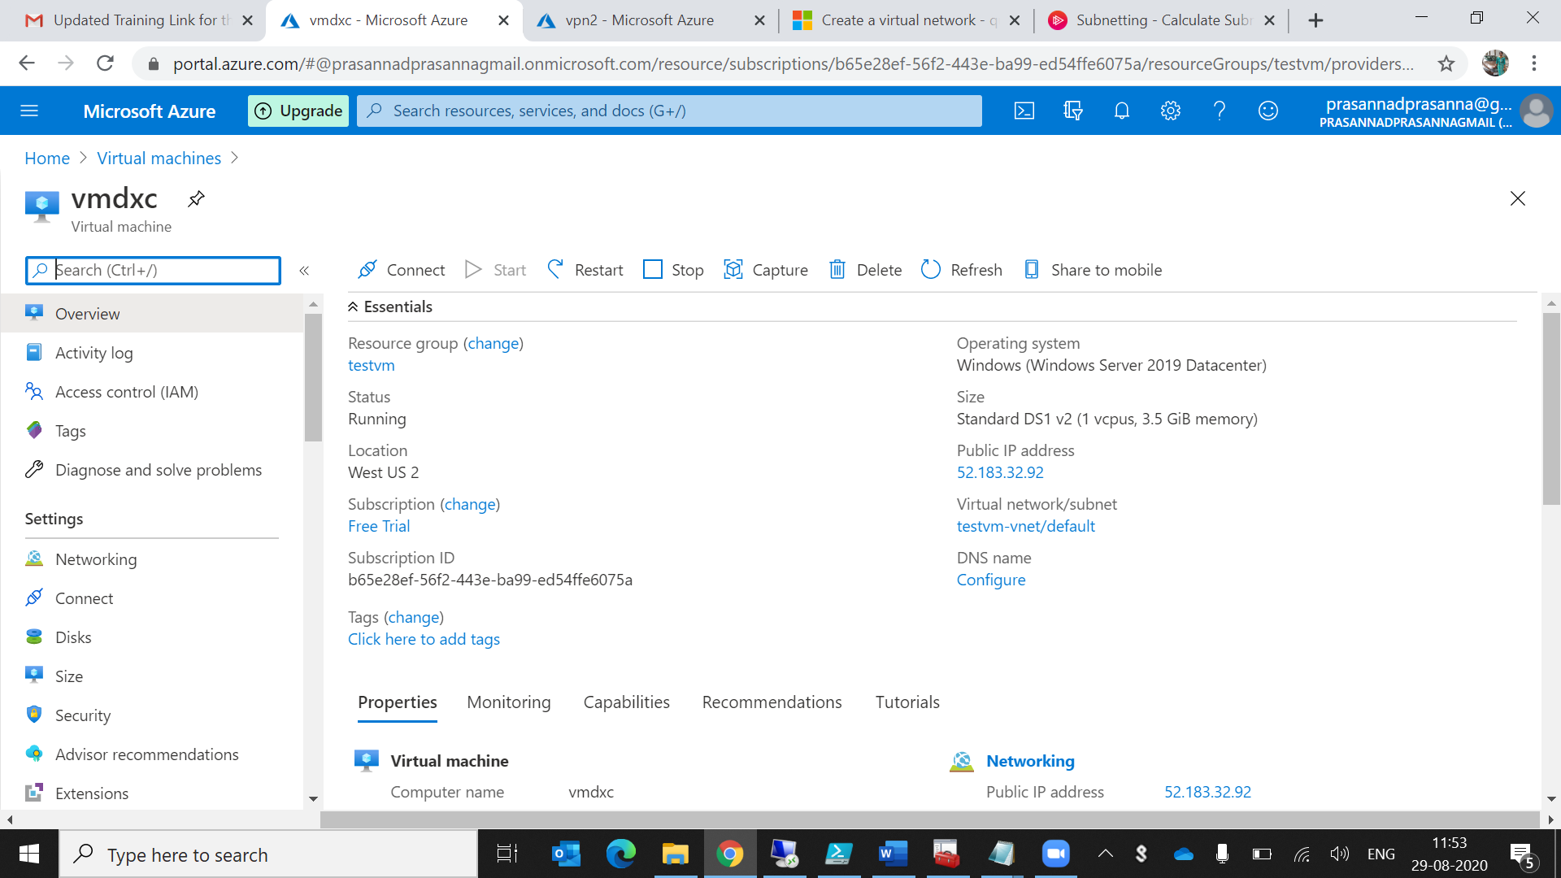

Create an virtual network.Delete the peering if anyone is connected to that virtual network.

Create the gateway to that network

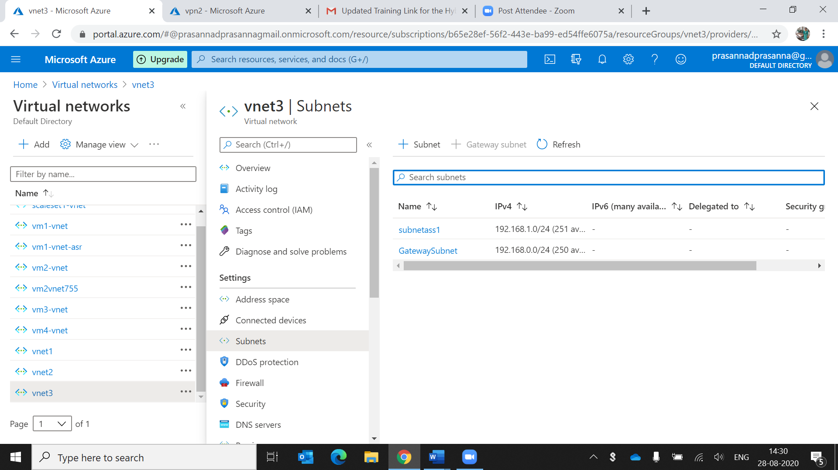

creating point to site vpn

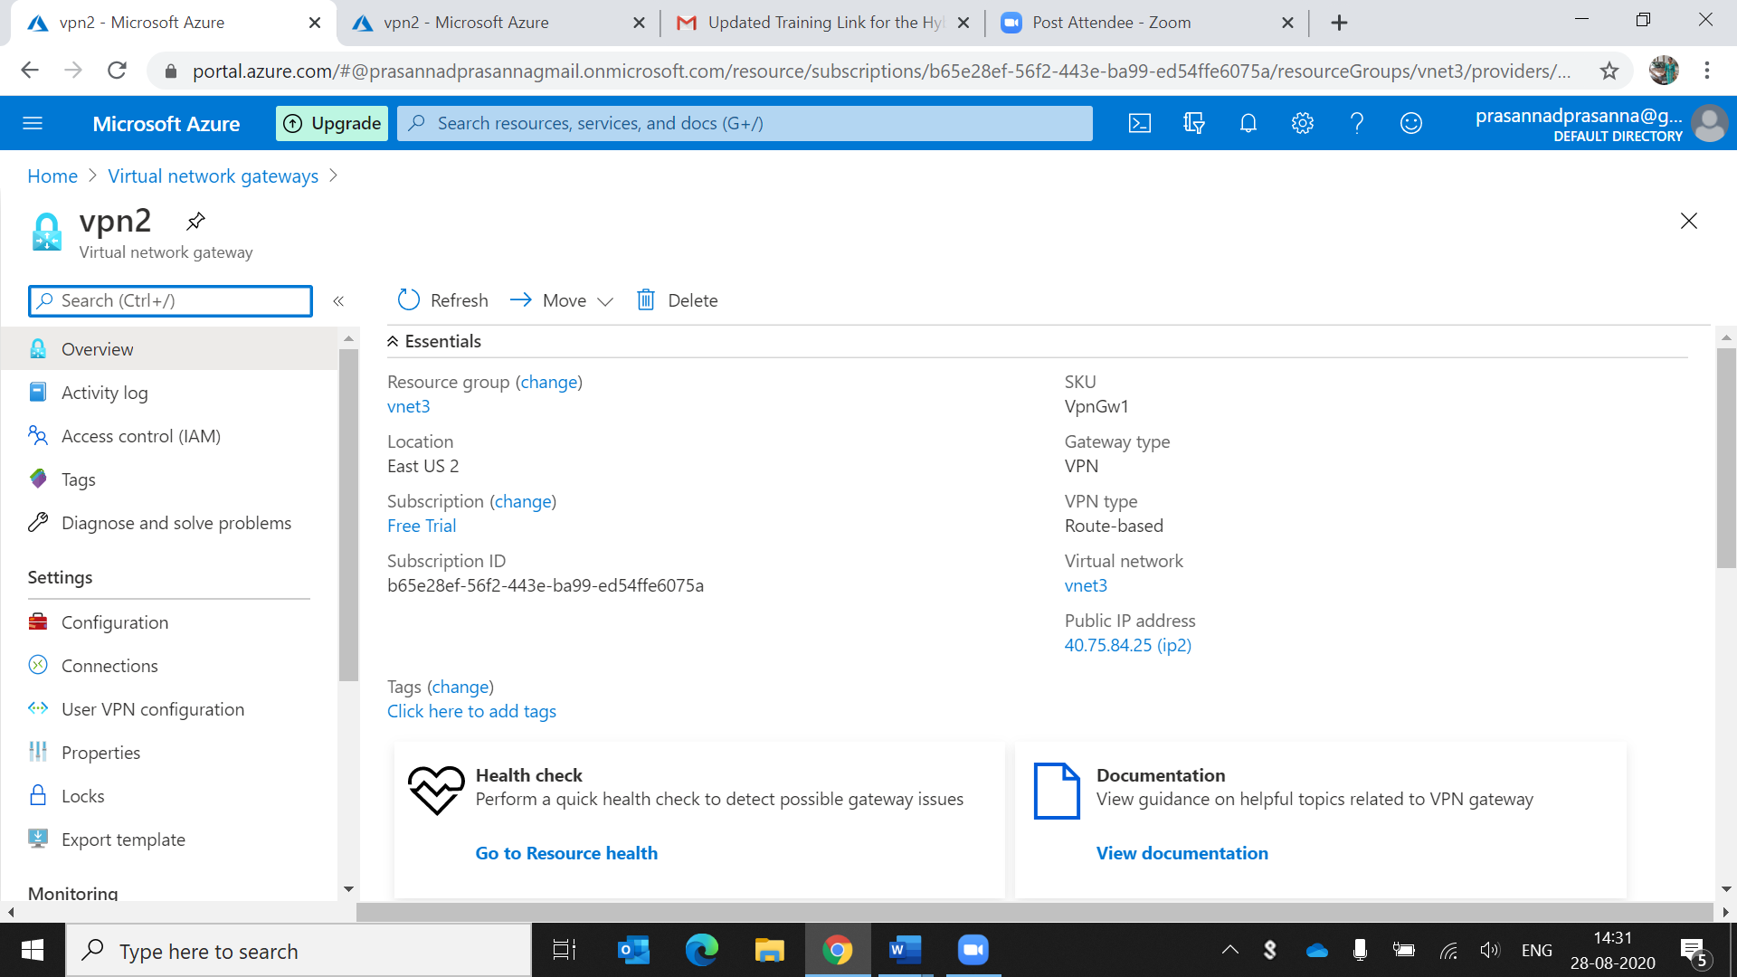

Here we are running the command to export the certificates in powershell ISE

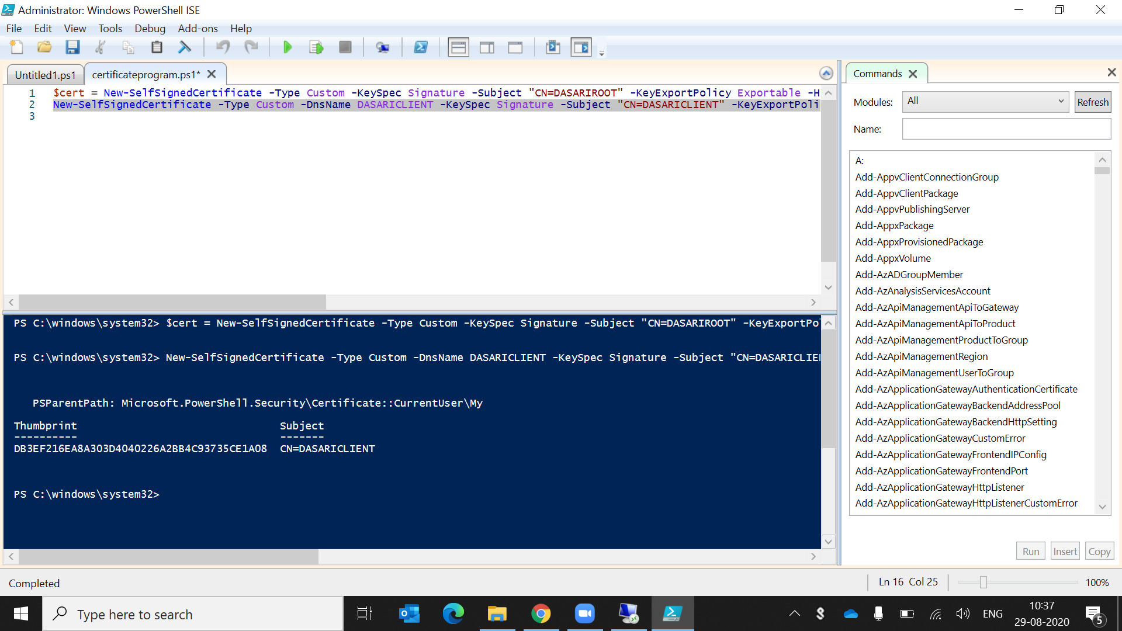

GO TO THE MMC CONSOLE->FILES->OPEN->CLICK CONSOLE AND IN THAT PERSONAL ->CERTIFICATES

Take the root certificate and export that certificate

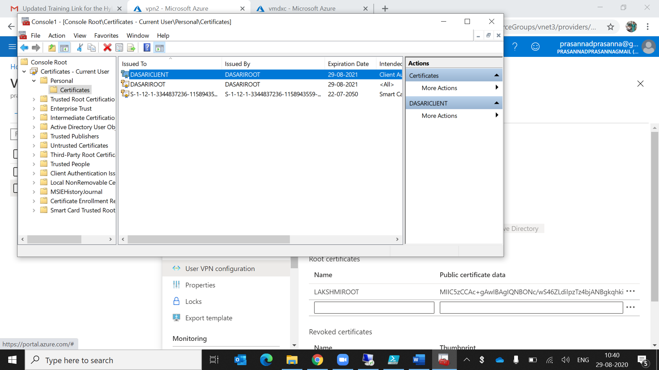

After that we open the root certificate in desktop .give right click open with notepad and copy that text and paste it in user vpn configuration

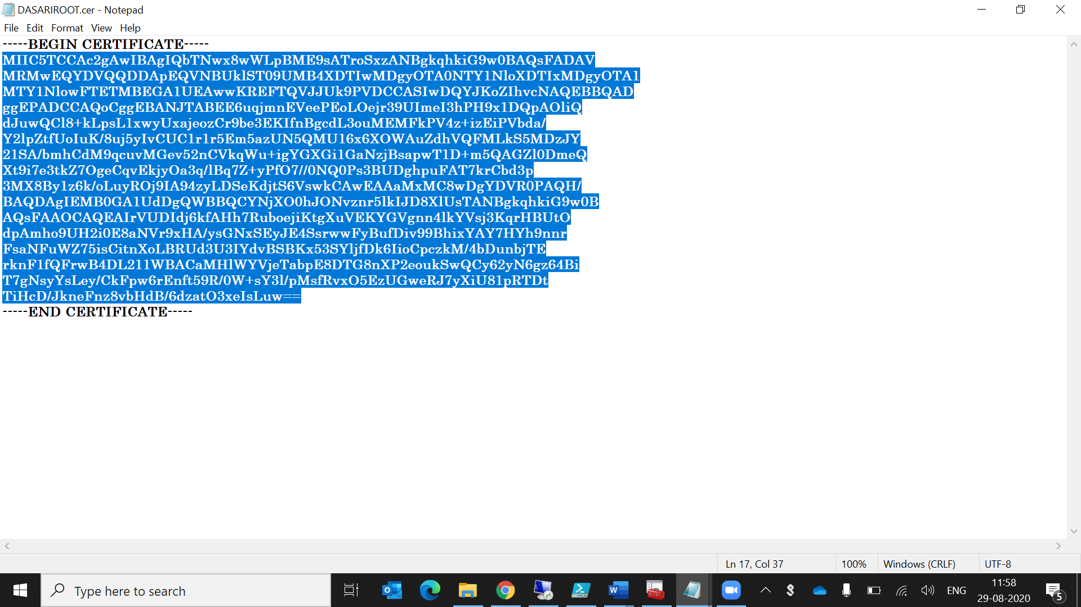

Go to the user vpn configuration and configure now

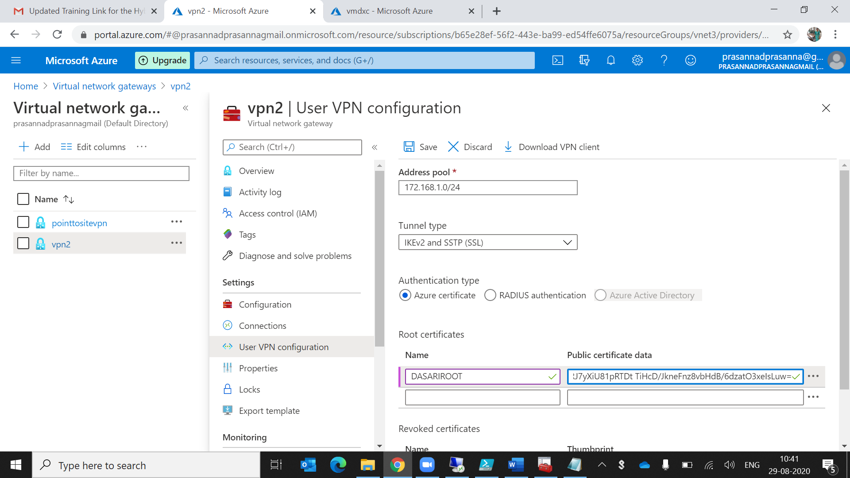

Save the user vpn configuration and download the client vpn

Connect to the vm using public ip address

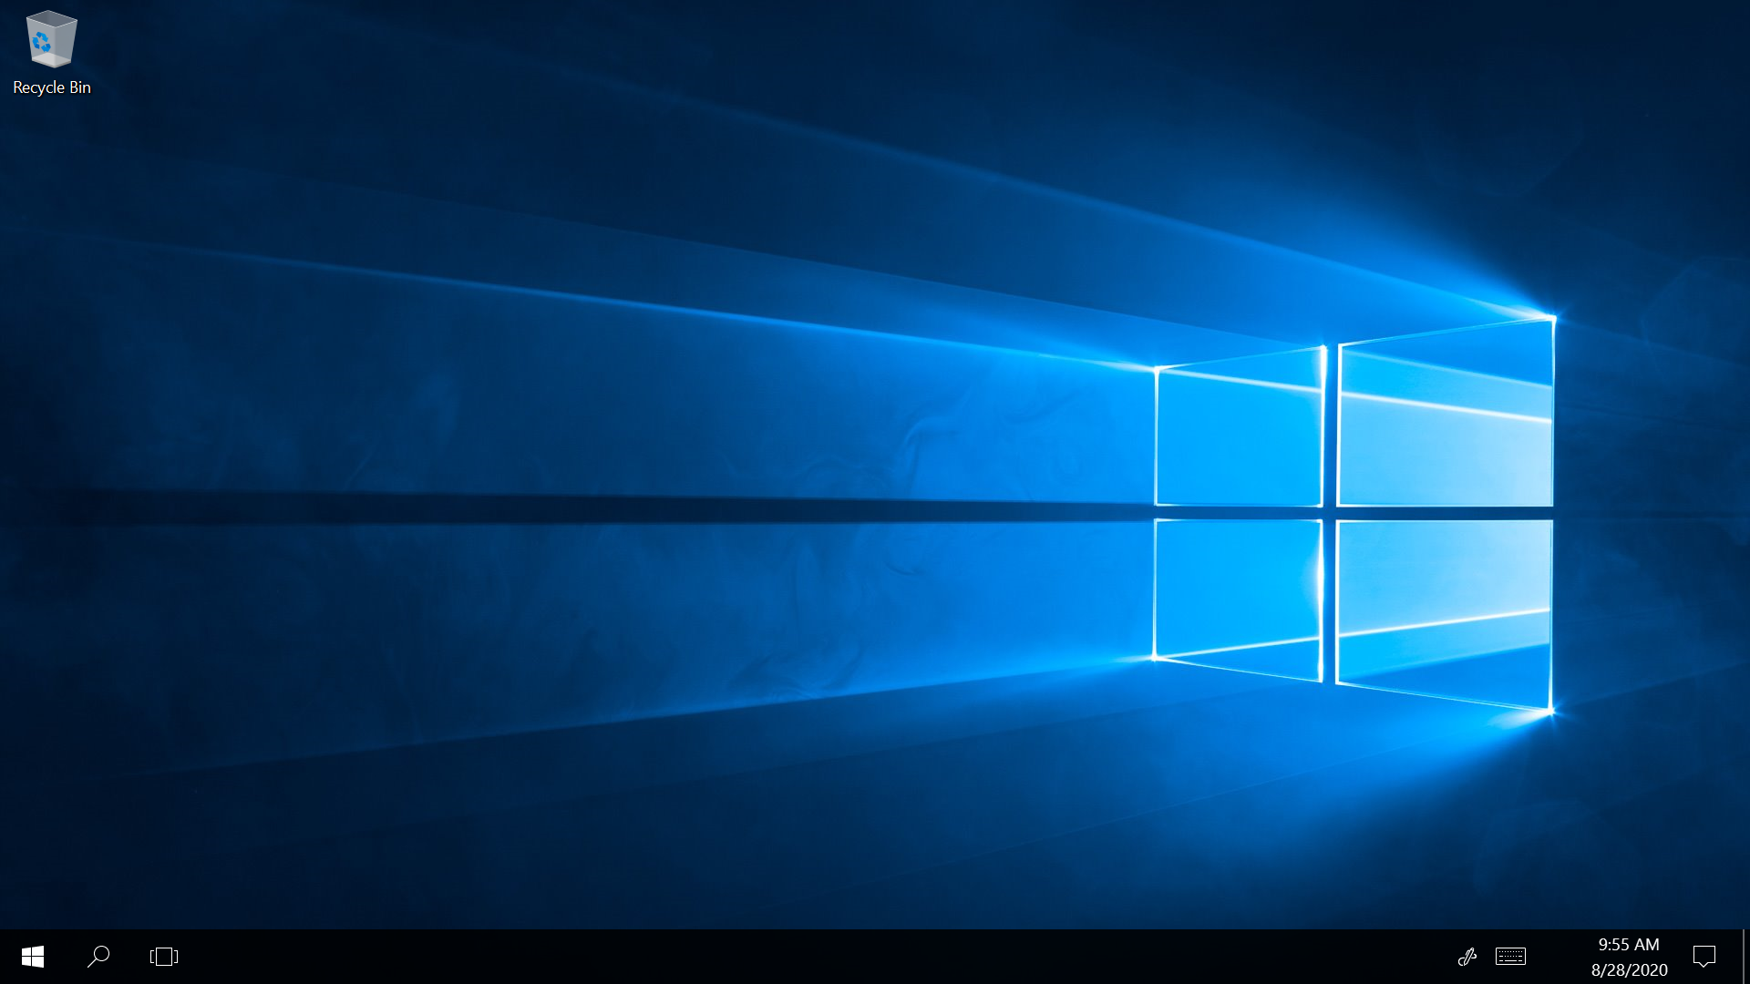

Copy and paste the root and client certificates in the inside vm and also copy paste the vpn client file

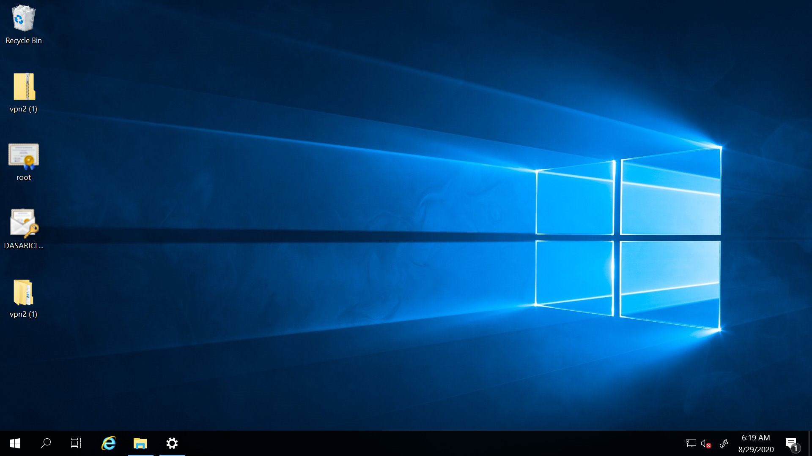

Install the client certificate in the remote desktop after that installation of client certificate we see vpn in wifi box

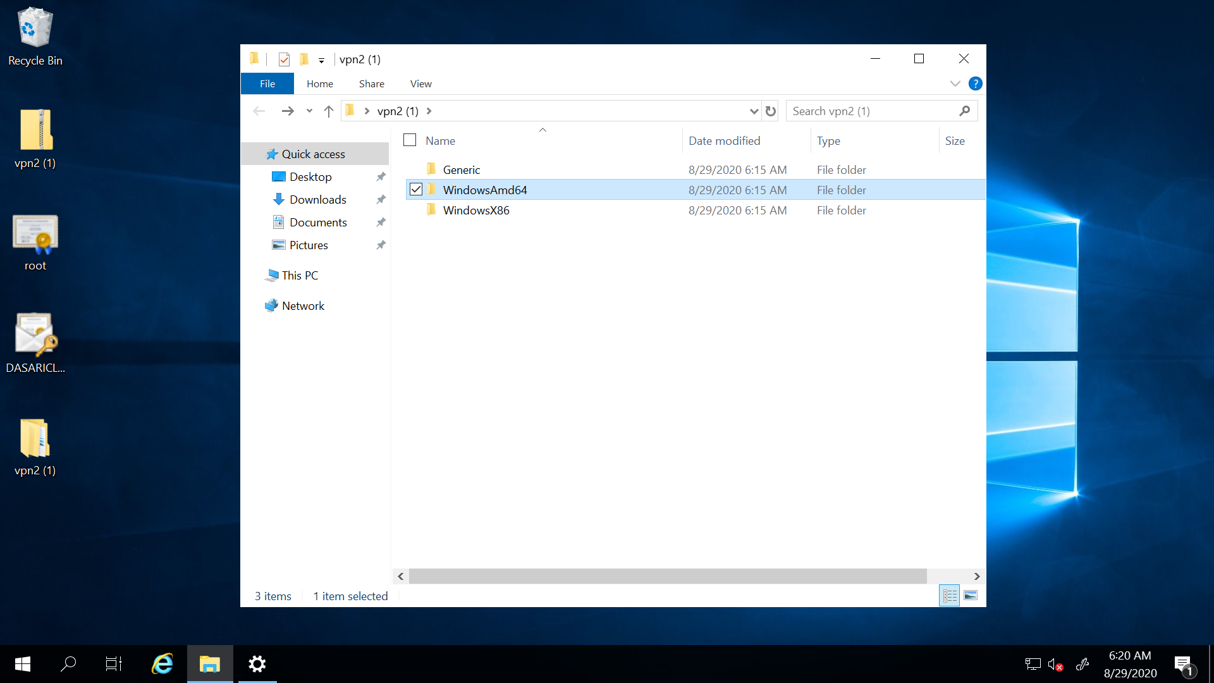

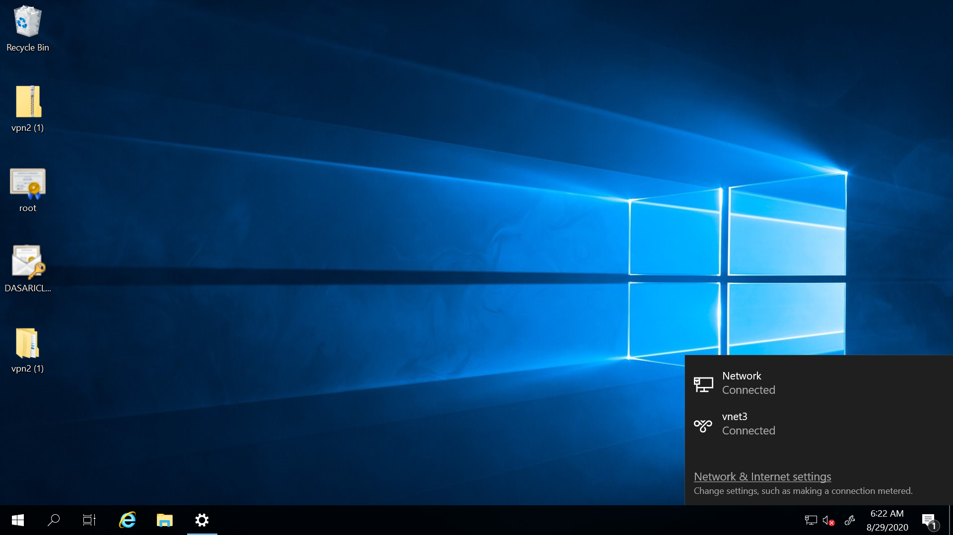

Go to the vnet and click on connect

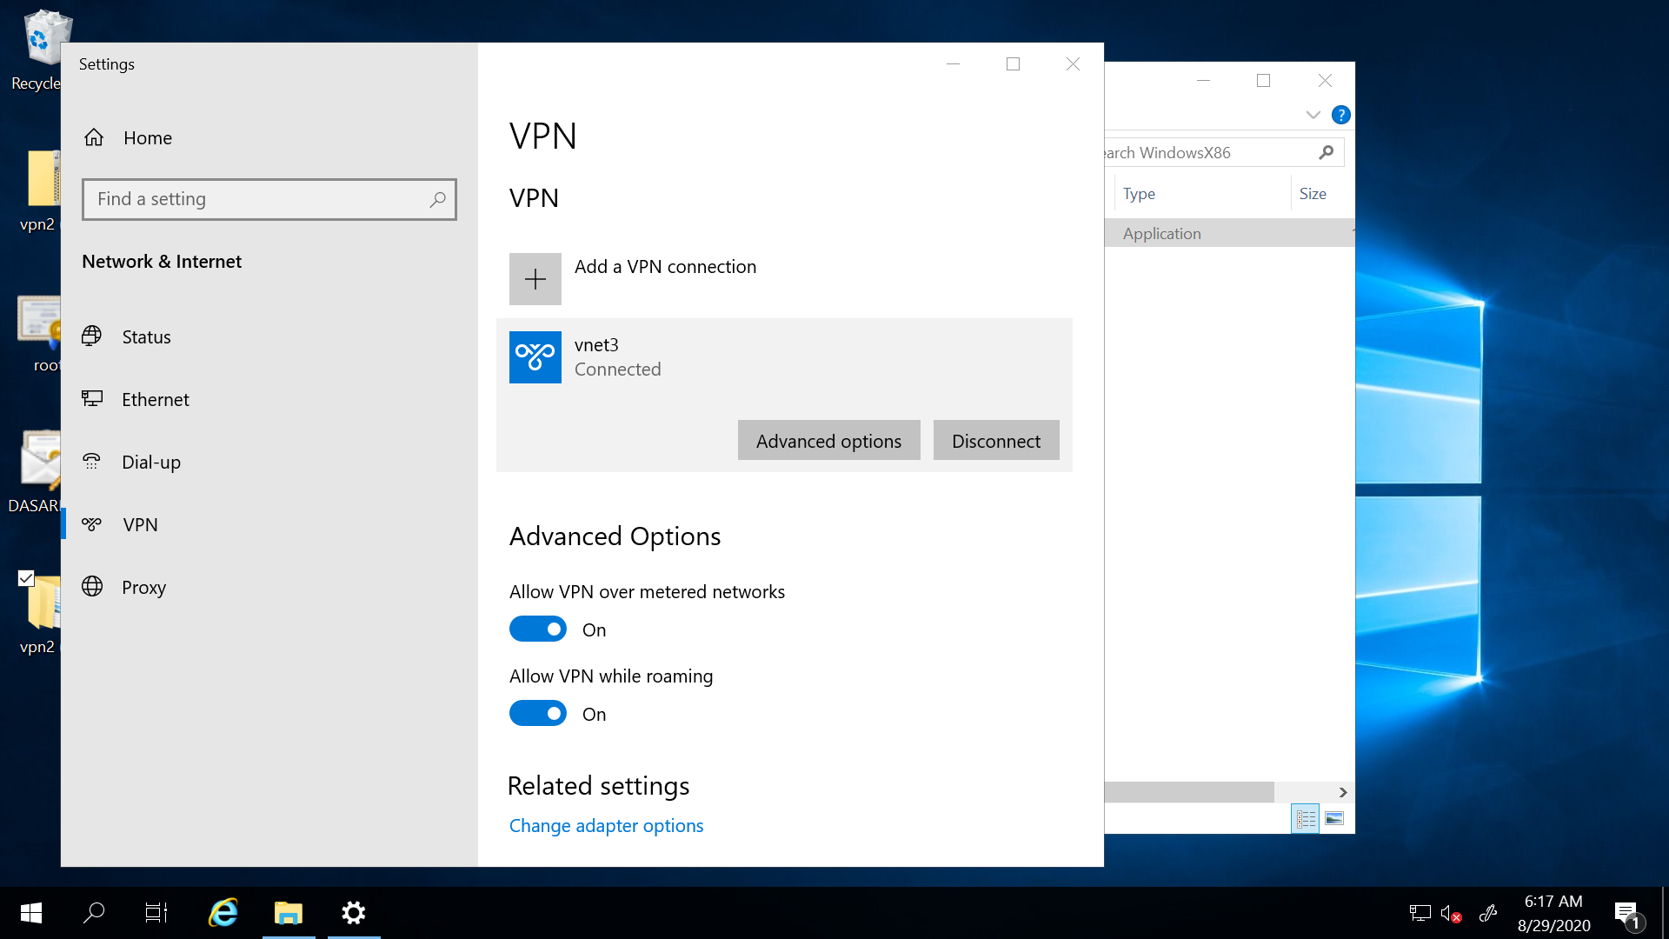

It is connected.

2.create a two web application in west us and central Us then attach to the traffic manager with Priority routing method

Create the two app services

This is one app service .in creating ap service we can fetch the any file and paste in the image field.so I take html file in docker hub wedsite

Go to the hub.docker.com and fetch the html file to create web application

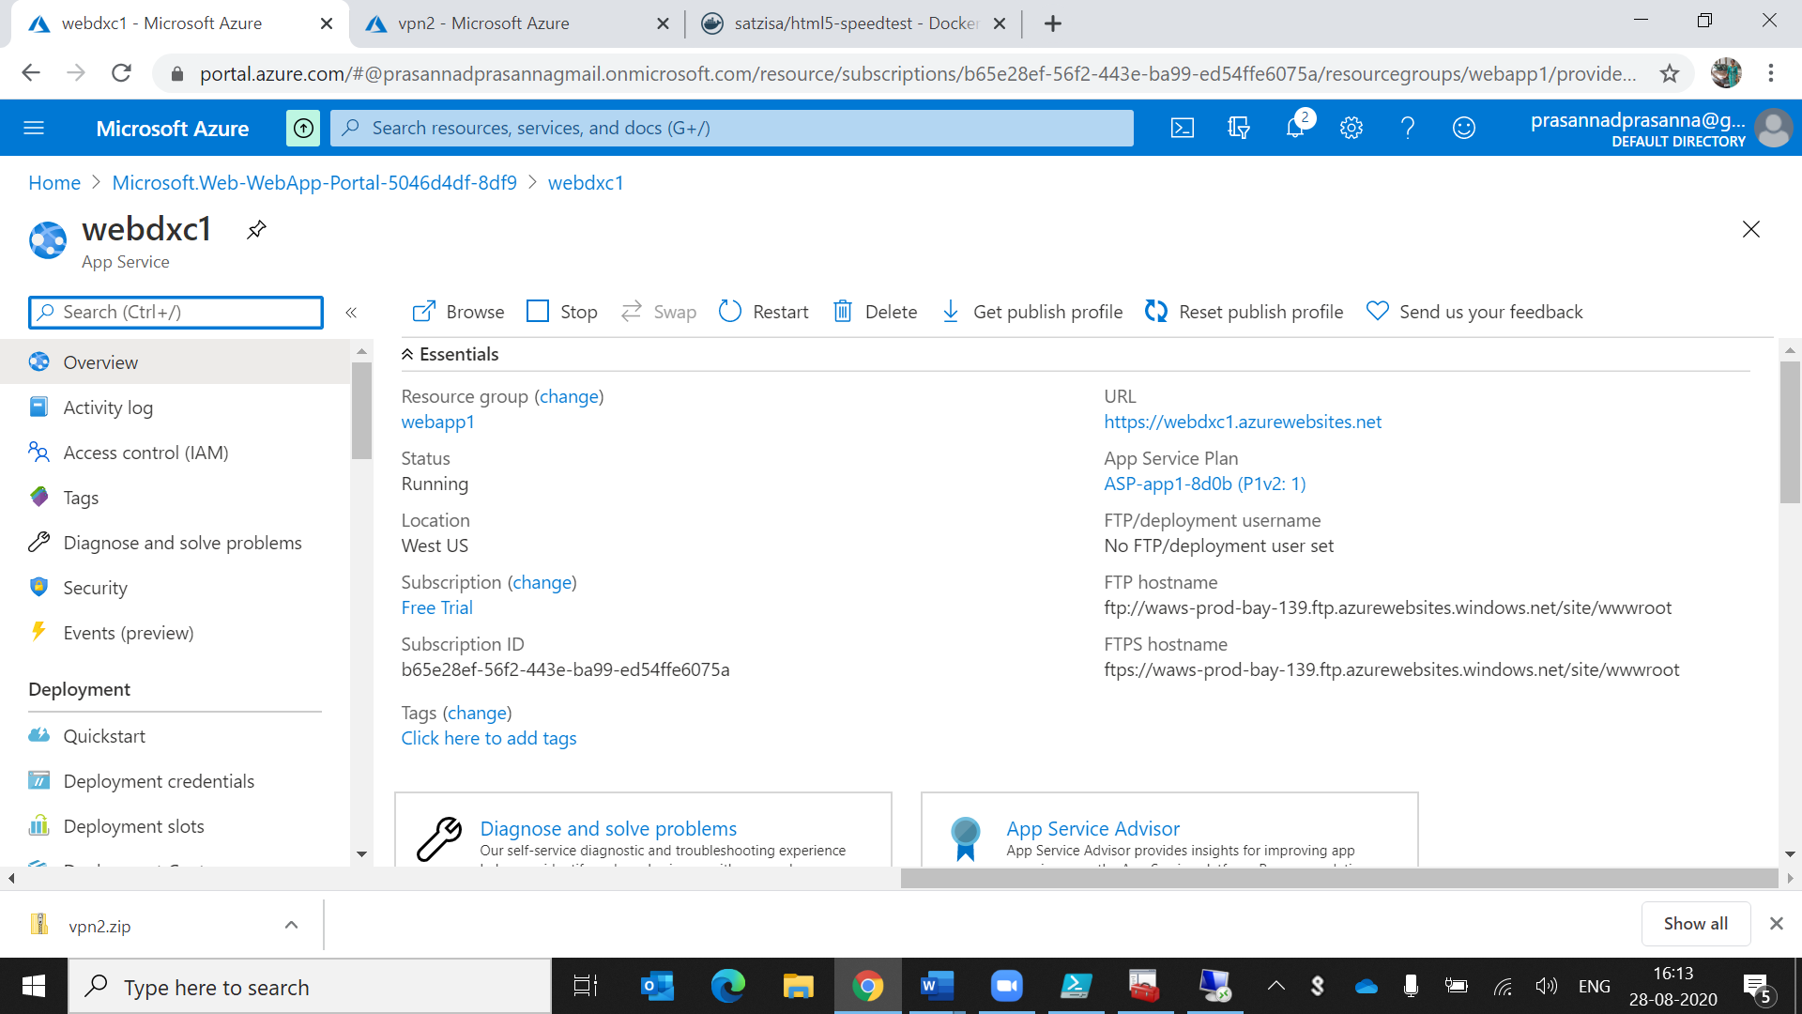

This is one html file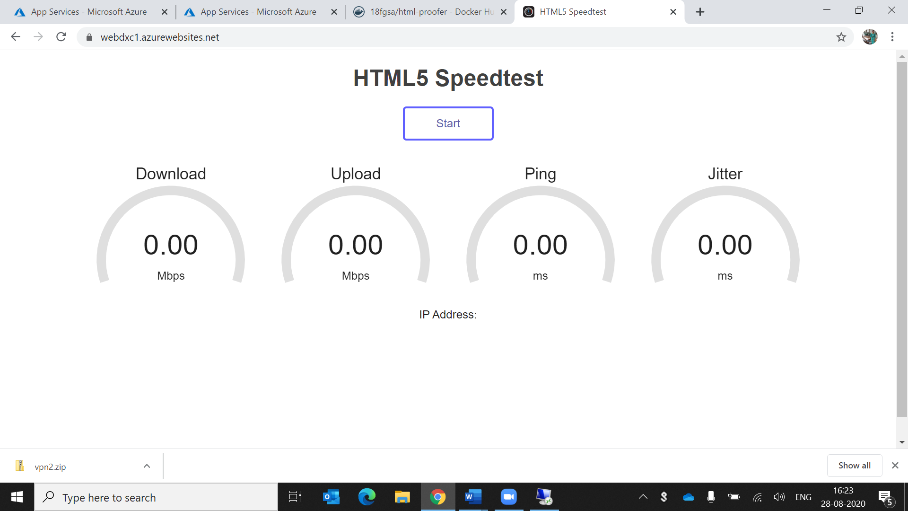

Create another web application using location as central us

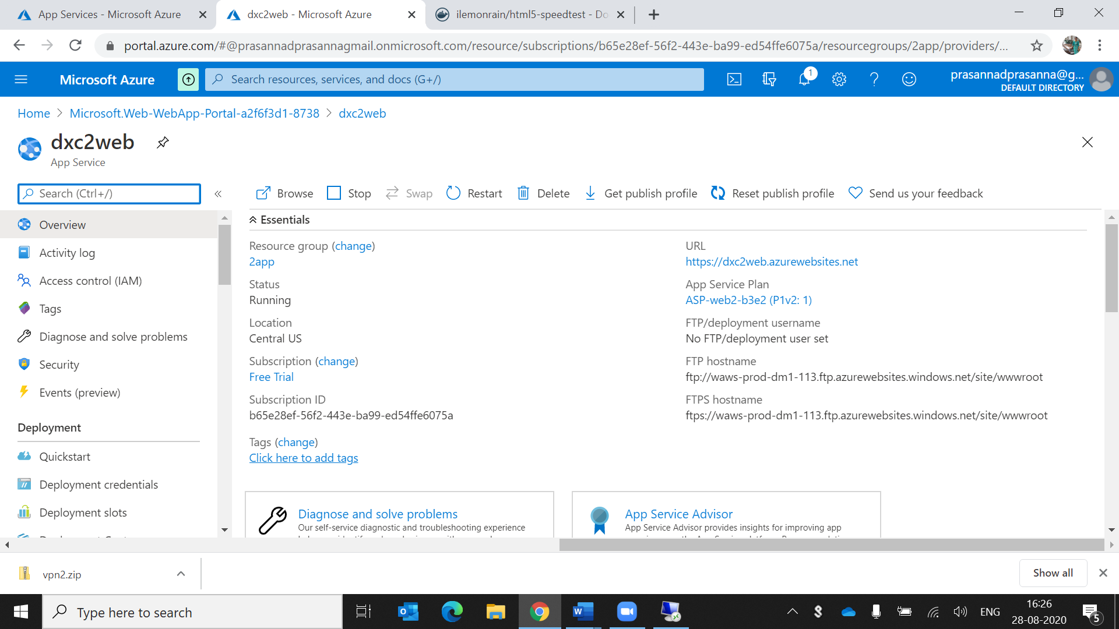

This is another html file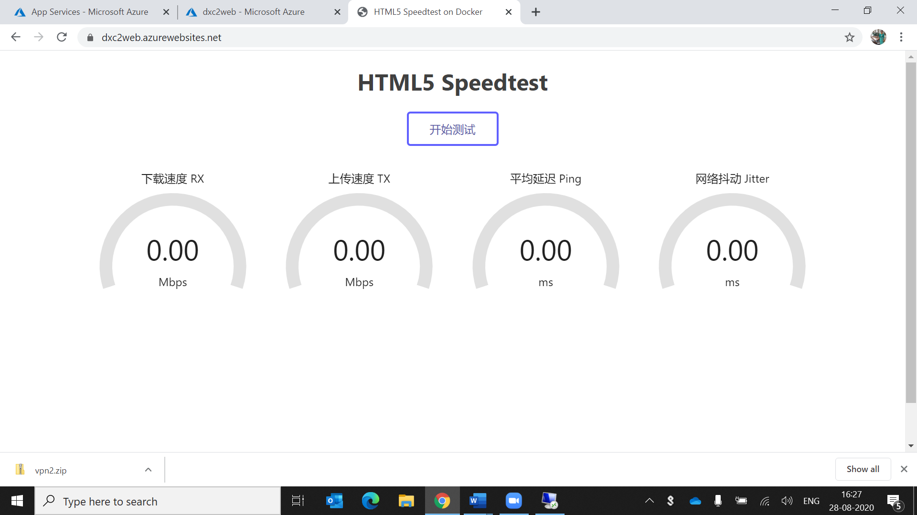

Now create the traffic manager profile in priority method

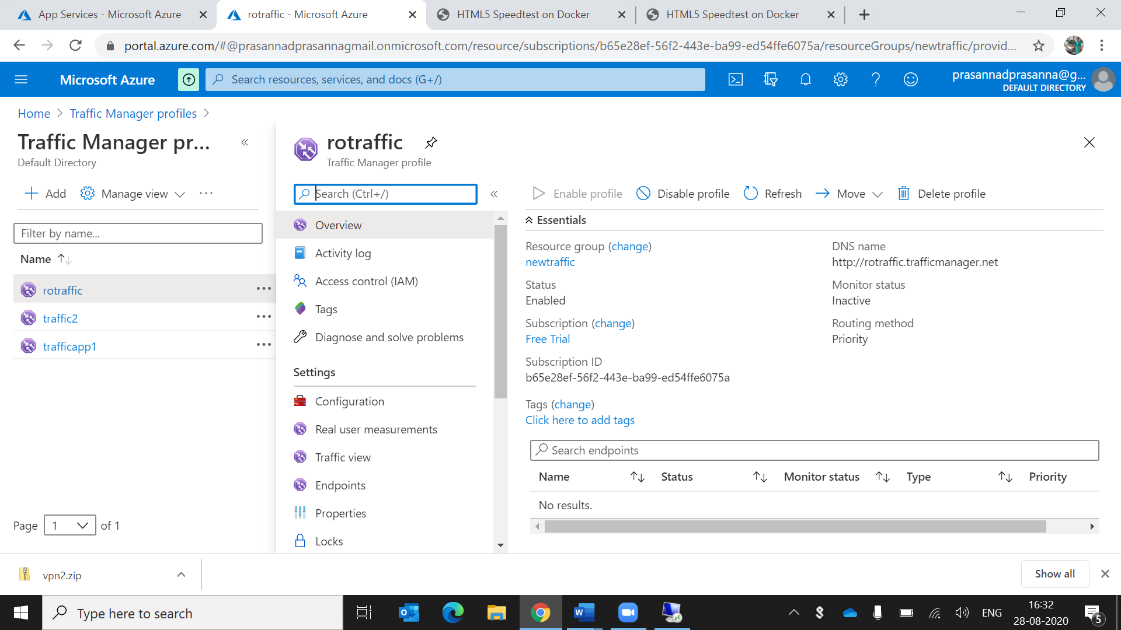

Using endpoints I attach the web applications to the traffic management

I create two endpoints for connecting to the app services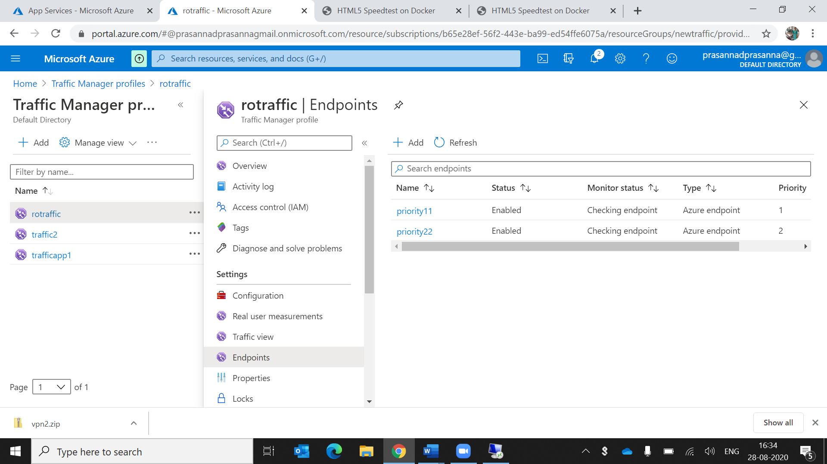

Copy that traffic url and paste in the browser

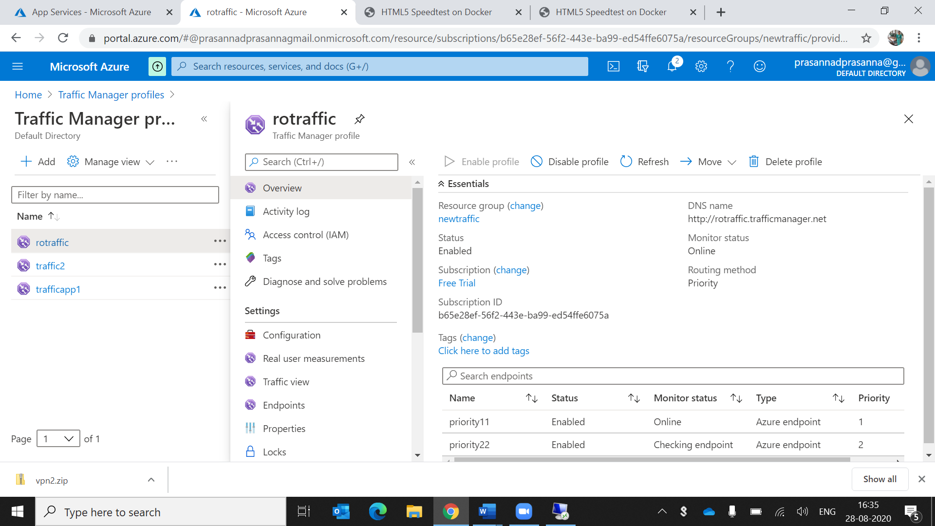

By accessing the above url we can get the first html file because in endfile I give 1st html file has first priority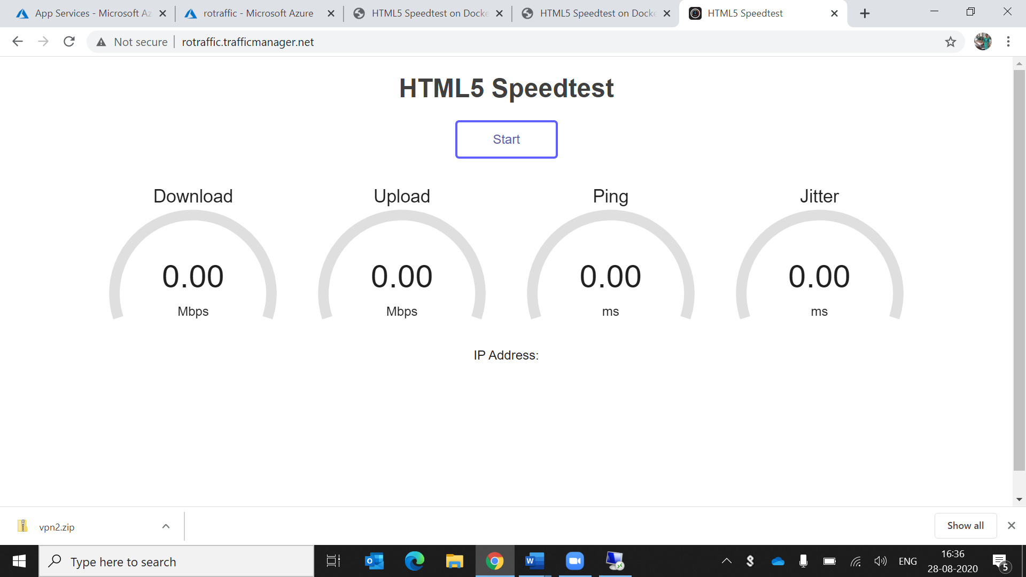

So we can disable the first priority and enable the 2nd priority in that case we get the 2nd html file

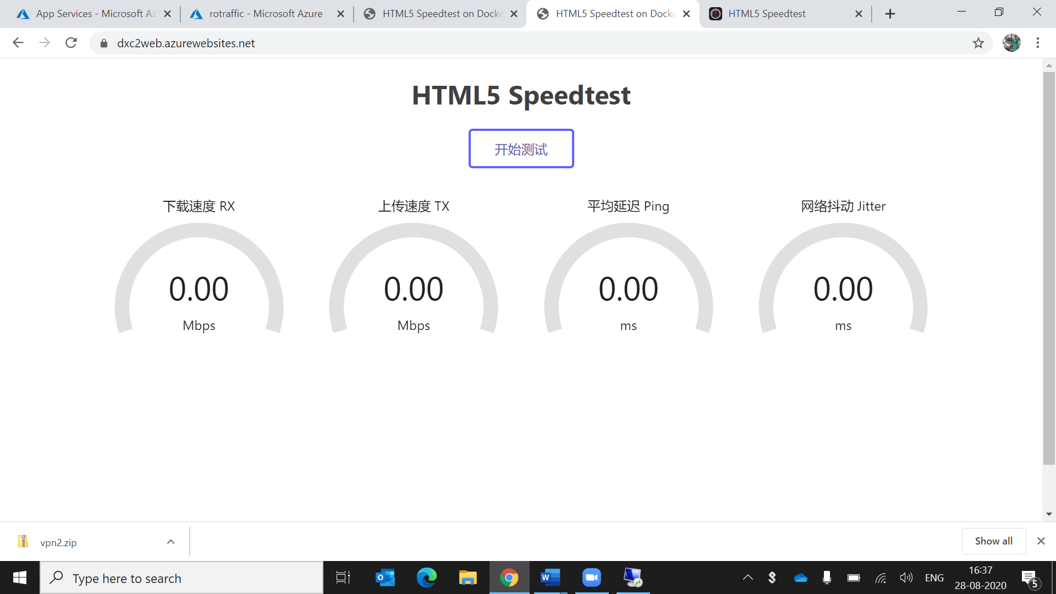

3.create a windows server with AD installed and integrate with Azure AD

Go to the anyone of virtual machine and connect to the remote desktop using public ip address

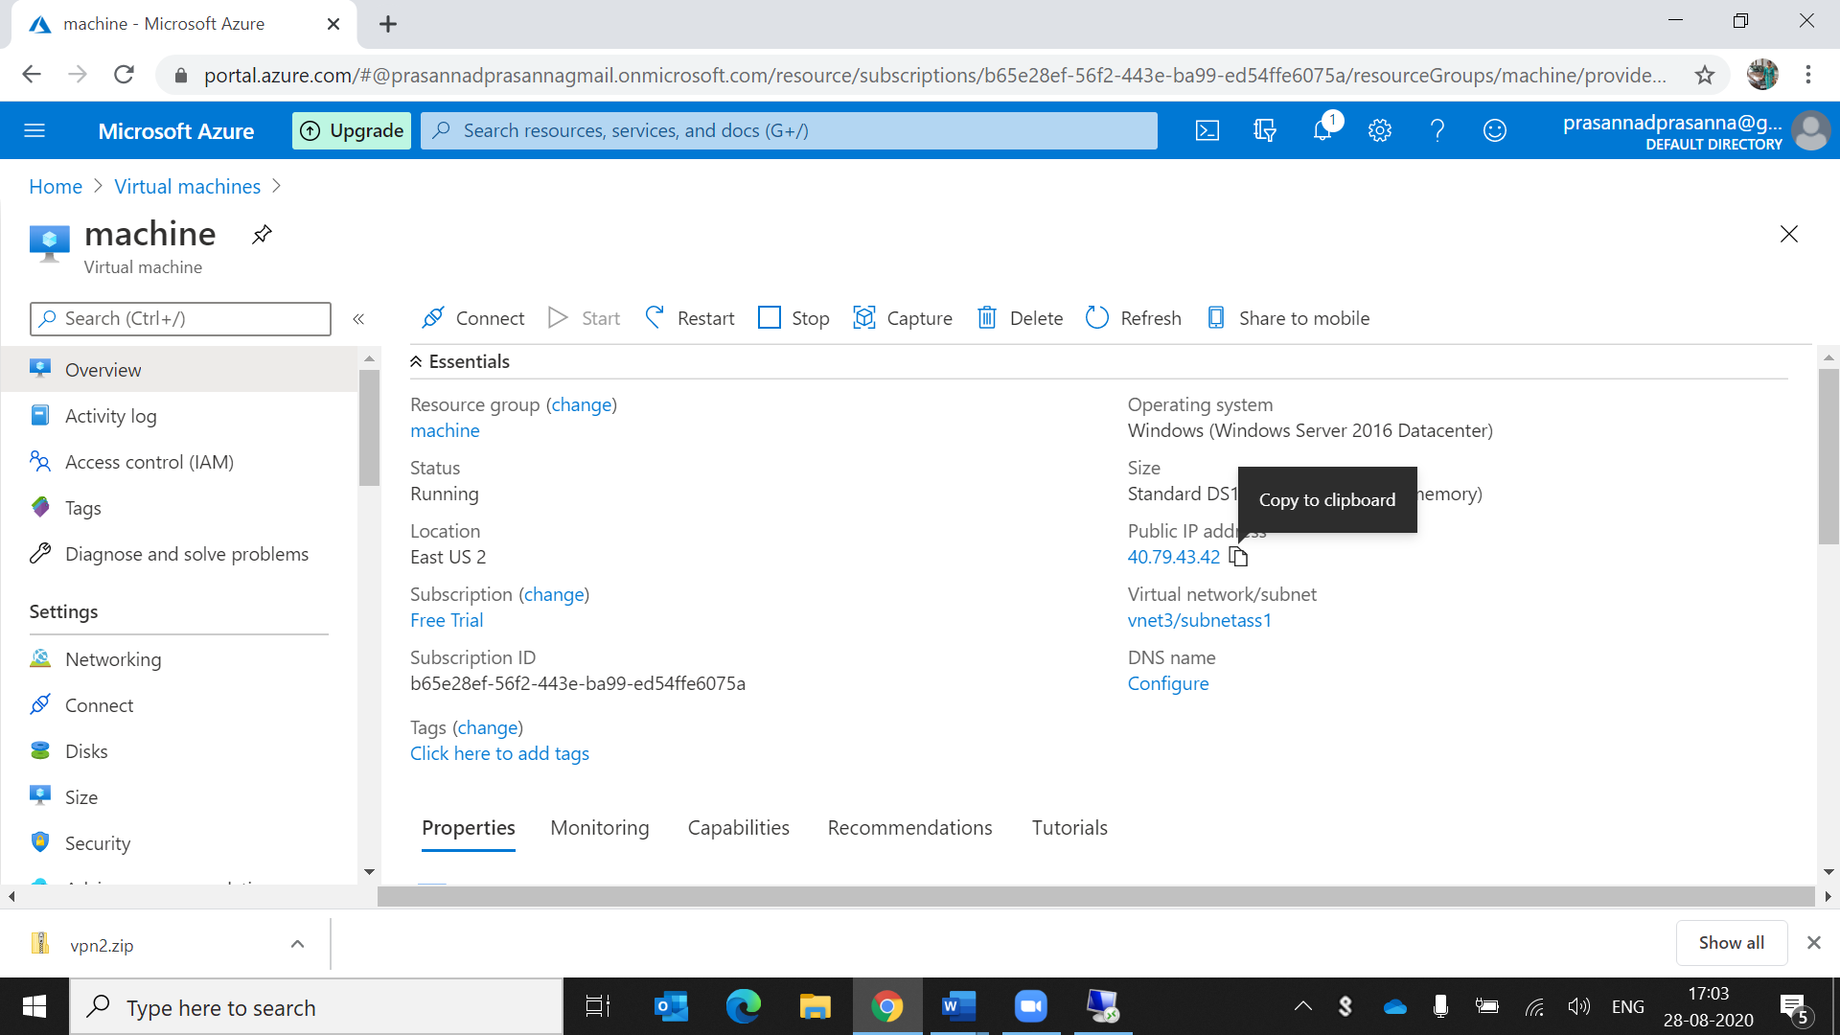

After connecting the screen like this.

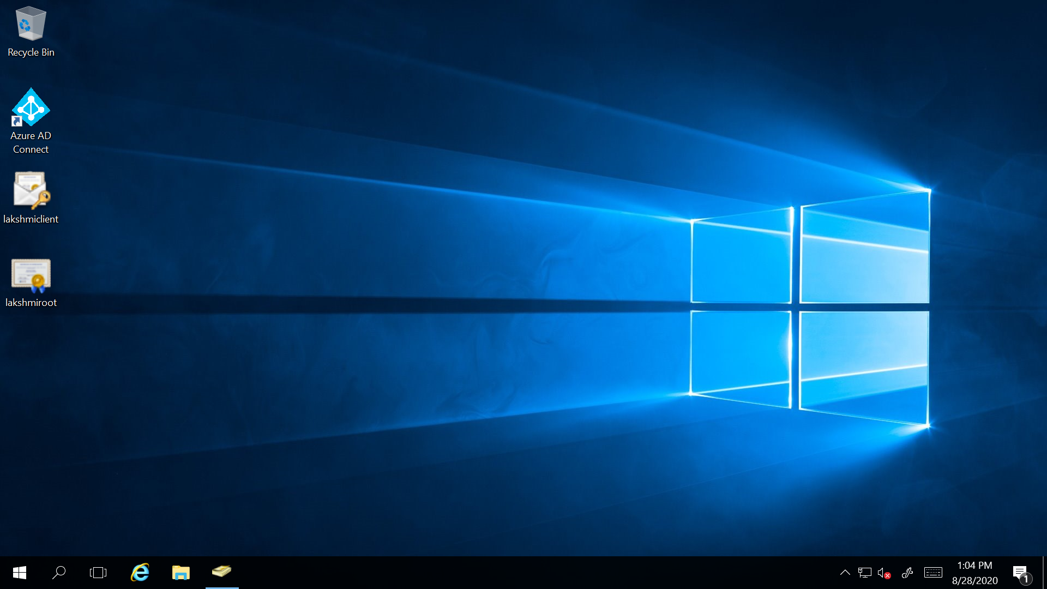

Completion of connection.In remote desktop the steps are like this

1.go to the server manager and open the all servers in that click the AD DS server in that click the promote the server after that install that ad ds.

2.Go to the browser and download the MICROSOFT AZURE AD CONNECT and install that application

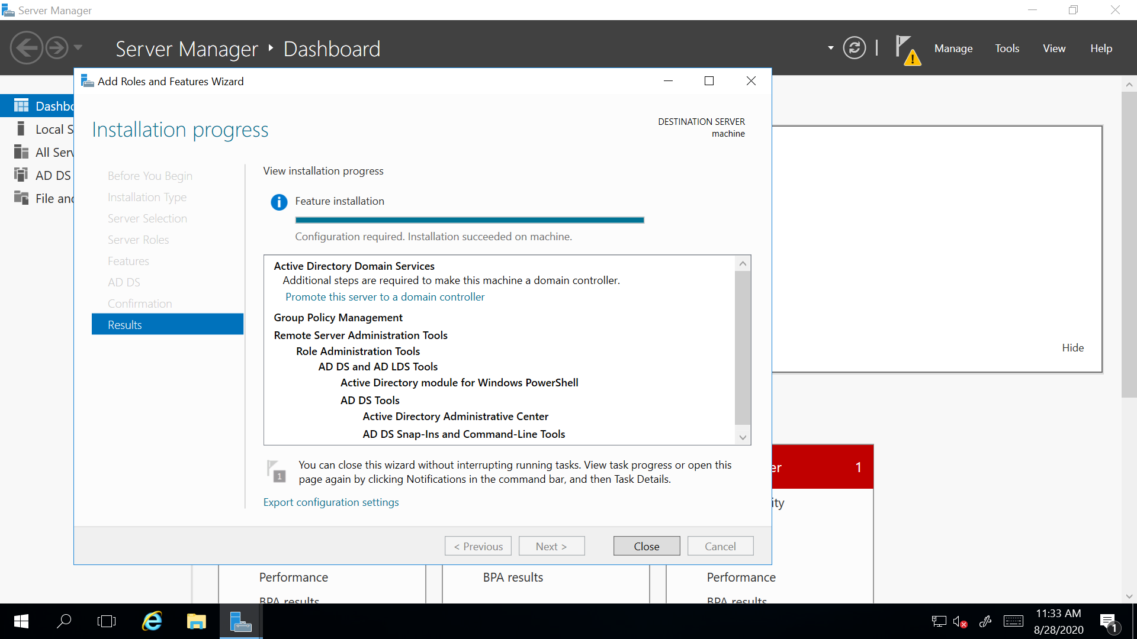

Then go to the azure portal.

3.In search bar type AZURE ACTIVE DIRECTORY

4.In that click the users(in overview) and create the new users.the new users are created after that

5.go to the assigned roles (in the overview)search for global administrator and give the administrative previliages.After clicking that global administration we can see the Microsoft account

Credentials

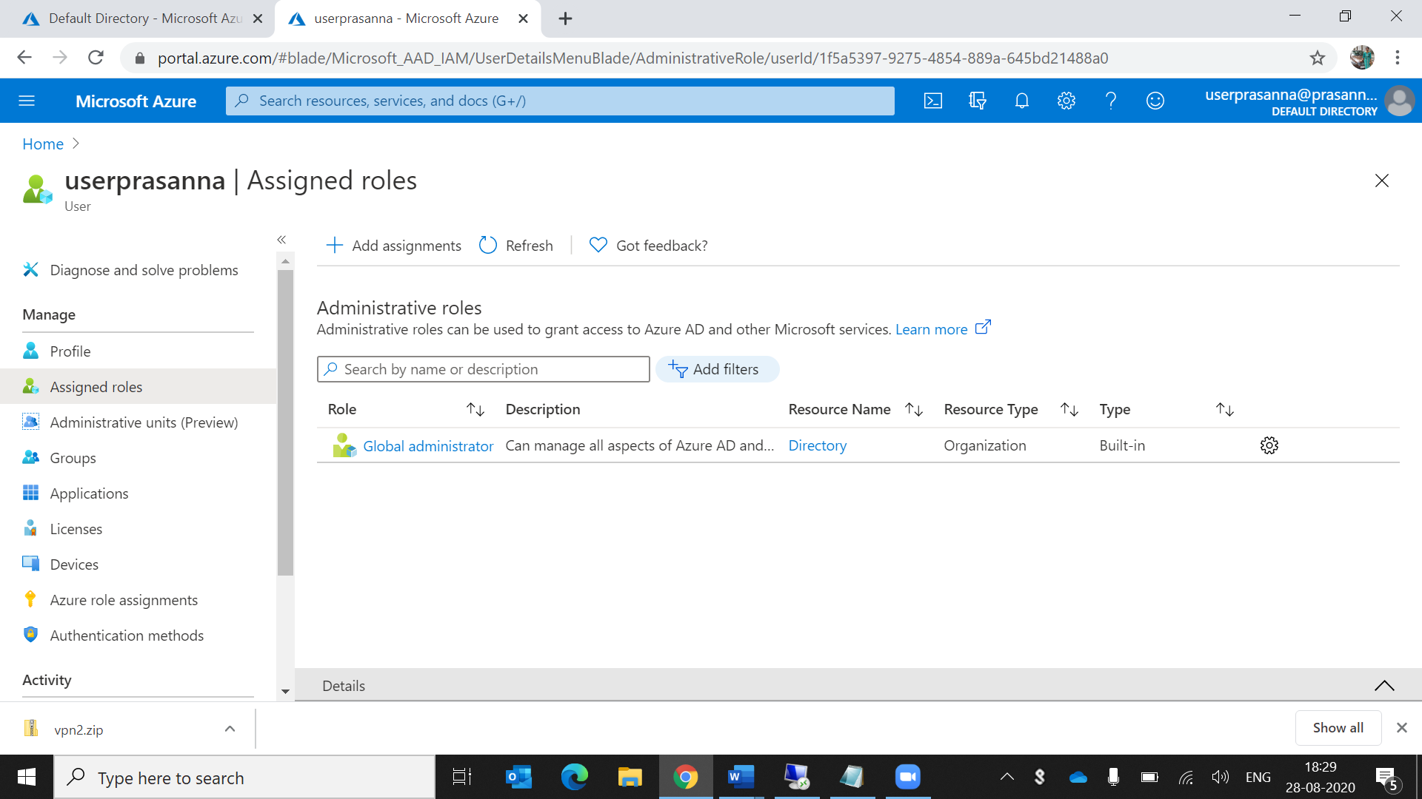

By using the Microsoft.com email sign in to the anotheraccount by using this email id 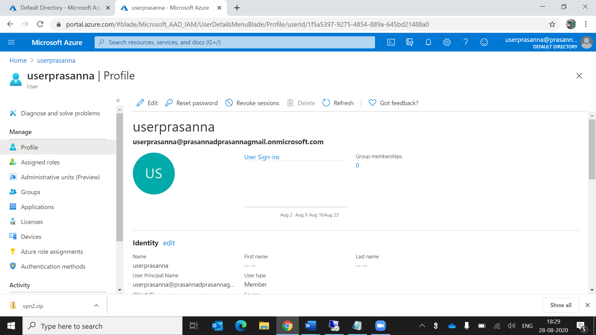

After give that Microsoft account email in the remote desktop and login with that account after go through the installation process

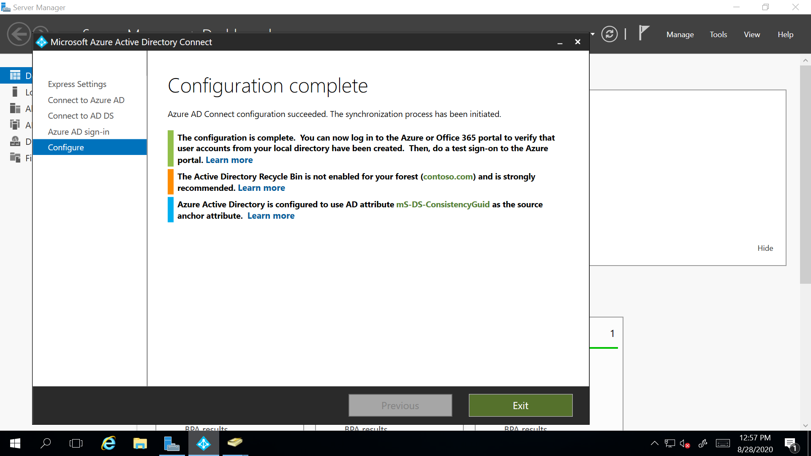

Then we can see the on-premises backup in azure portal in users.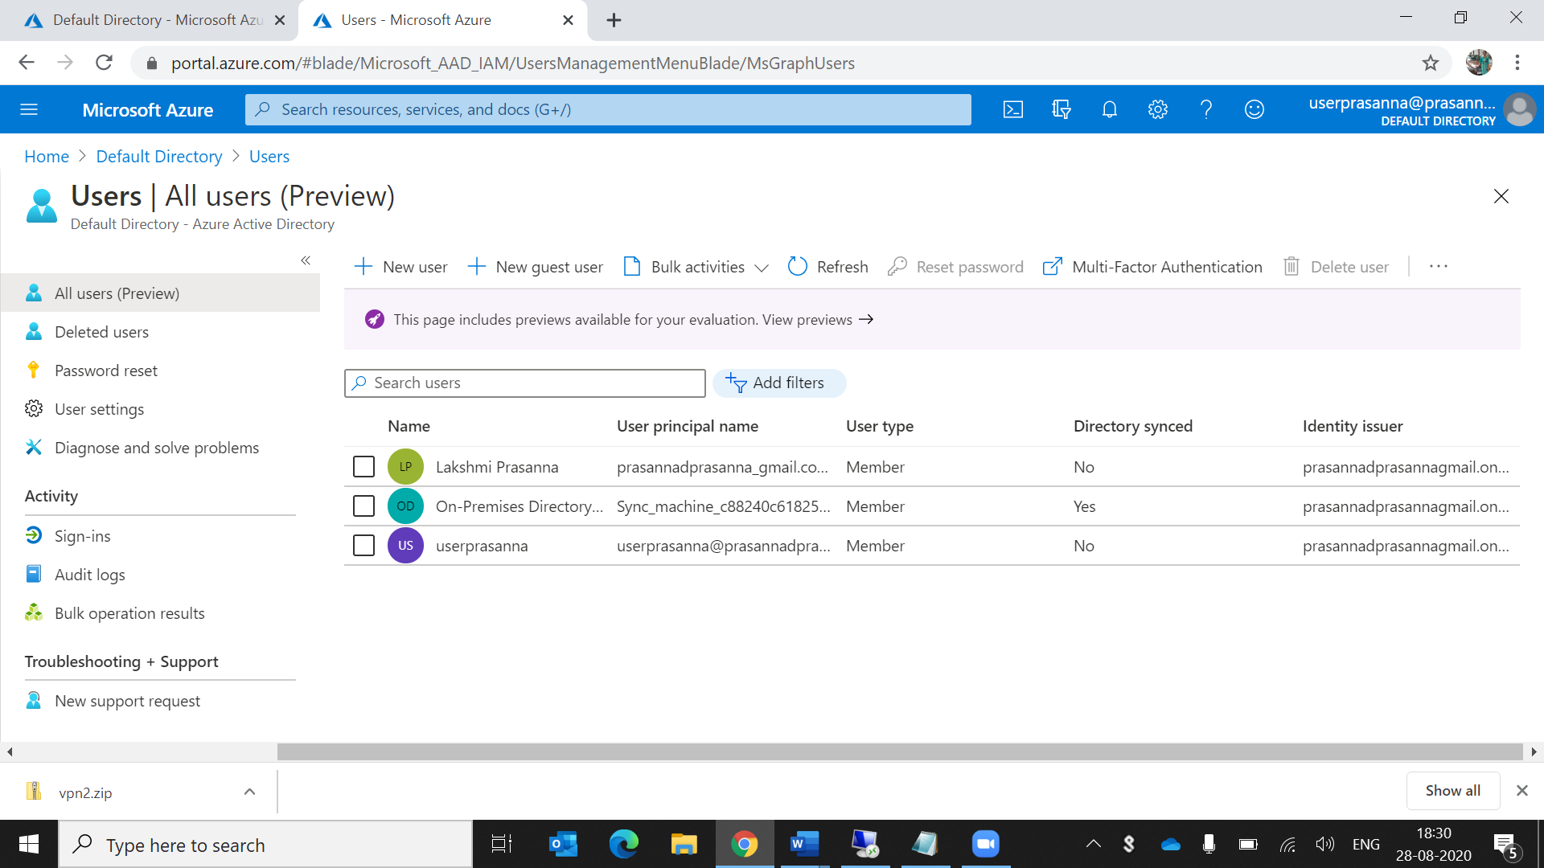

4. configure a backup to the VM you installed AD

Select which vm is connected to azure directory take that vm and give backup.By selecting the backup option in that vm and fill the places

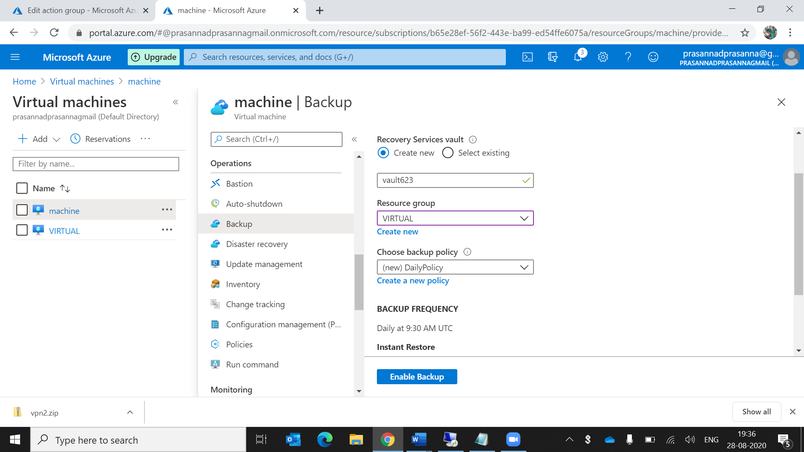

The backup is saved afrer that click on backup now then the vm is backuped.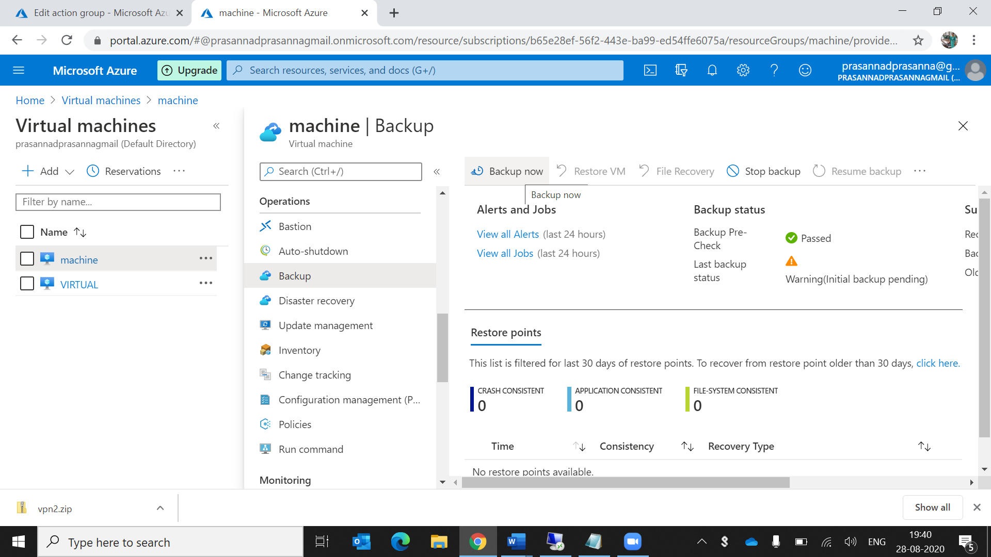

5.configure alerts for the VM

Go to the any vm and click alerts in the overview and fill the mandatory fields

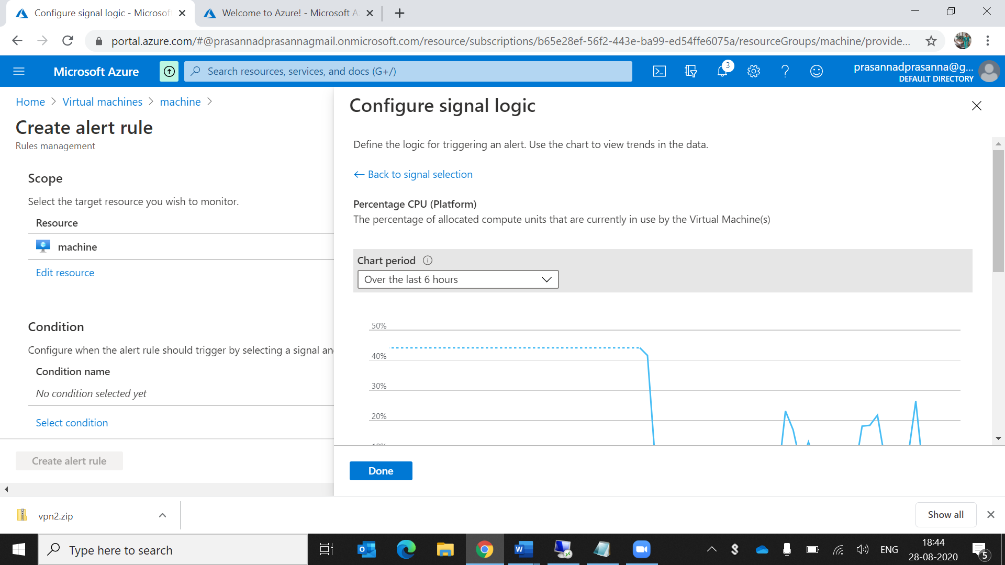

We are configuring the alert rule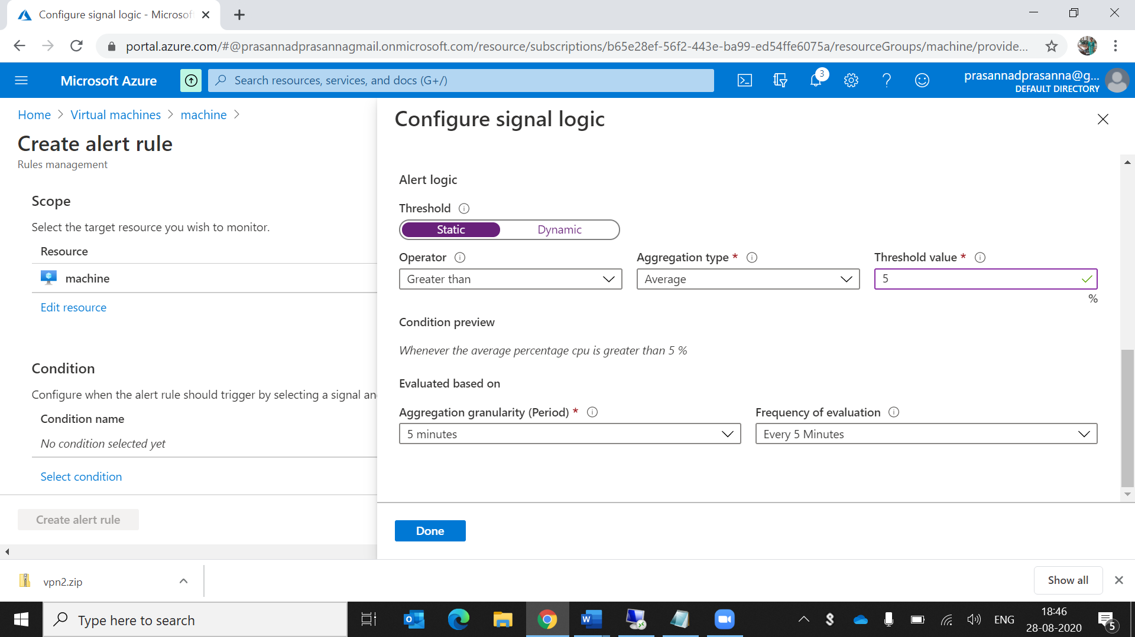

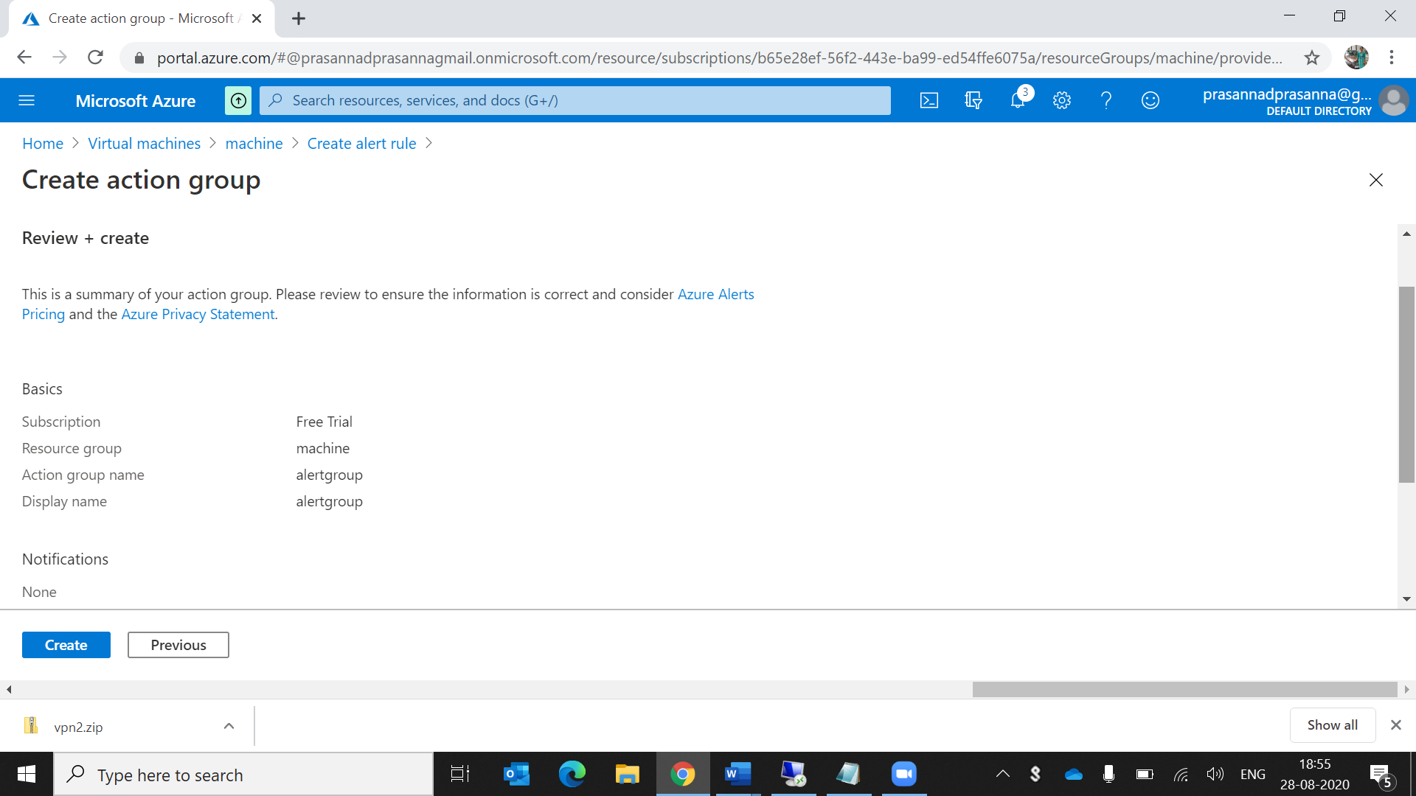

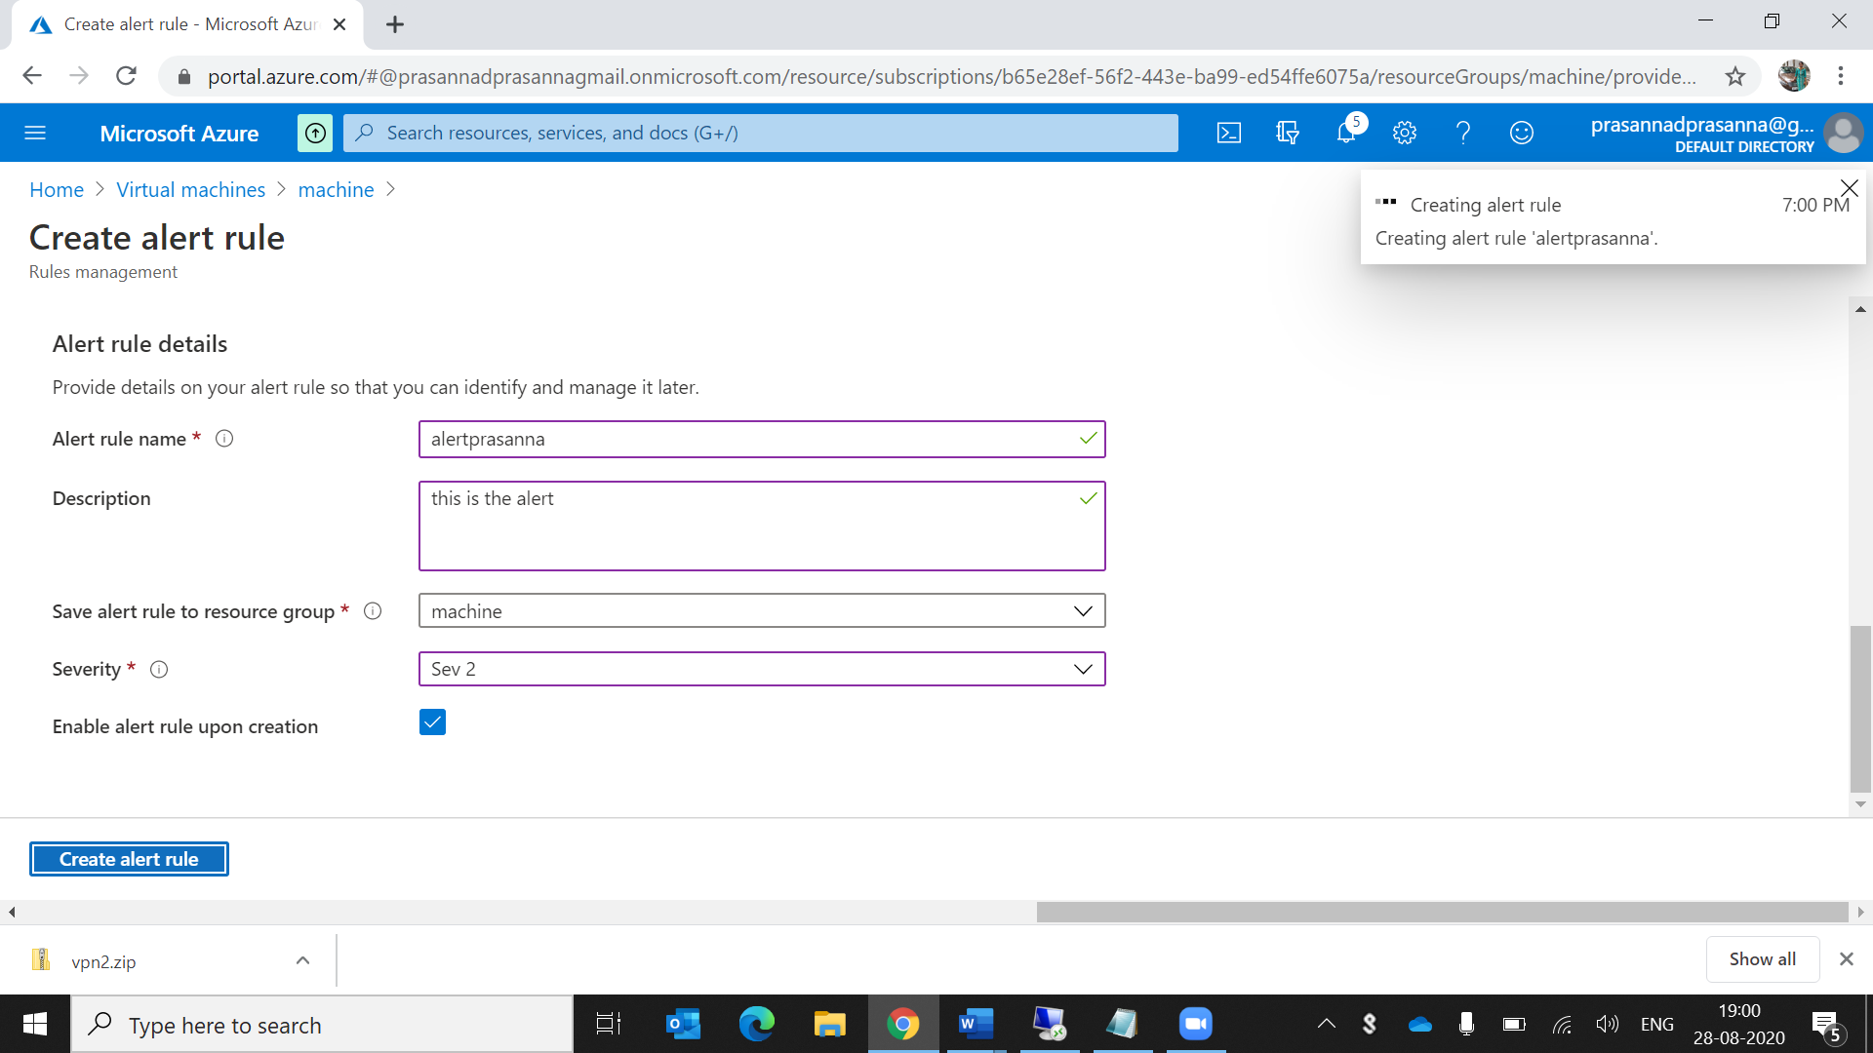

We are giving the text msg for alerting it should come to our vm when we open the alerts in that vm

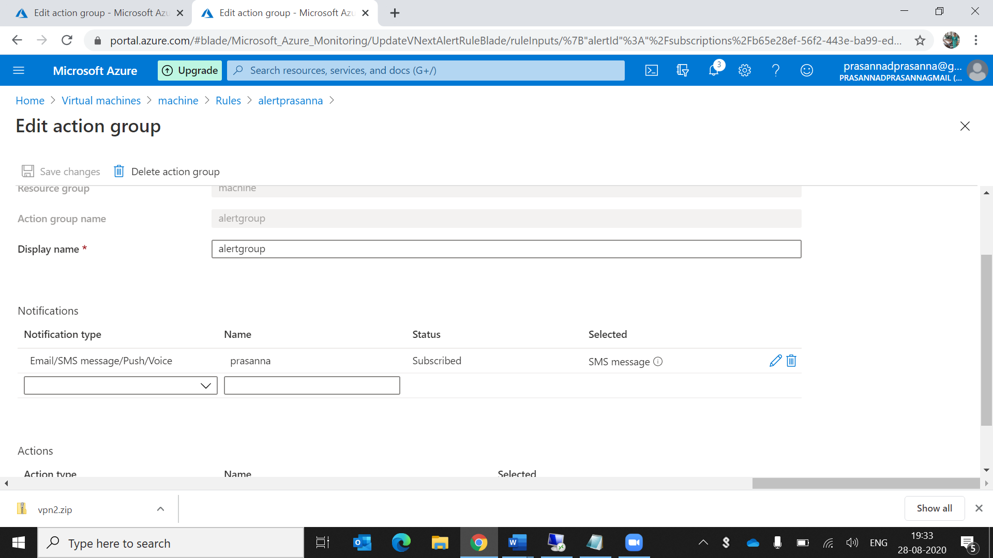

This is the created alert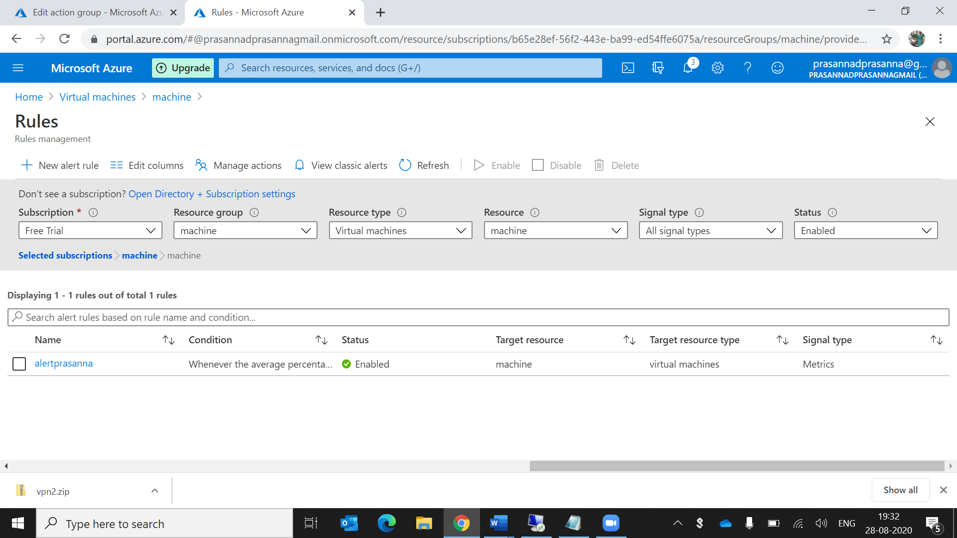

6.Apply any security policy to the subscription

Go to the security center in that go to the security policy and click on free trail then fill the fields

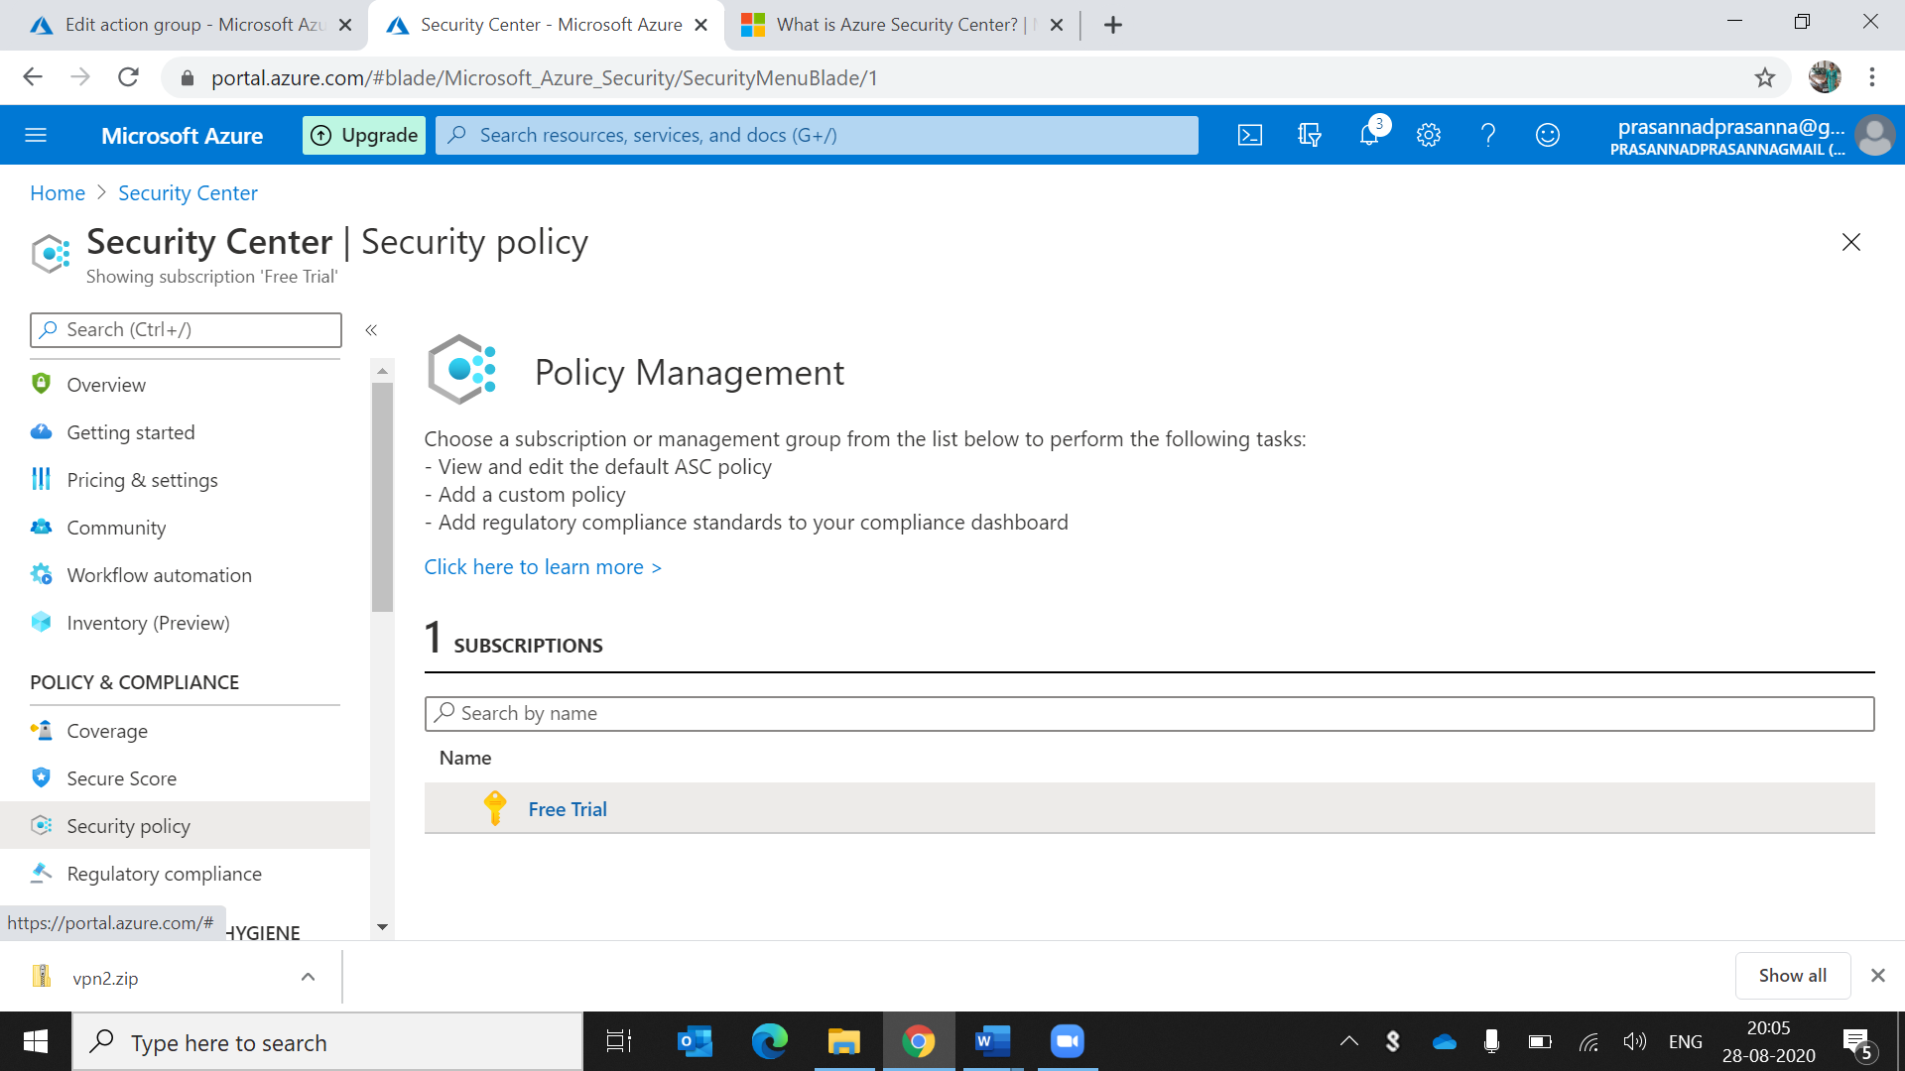

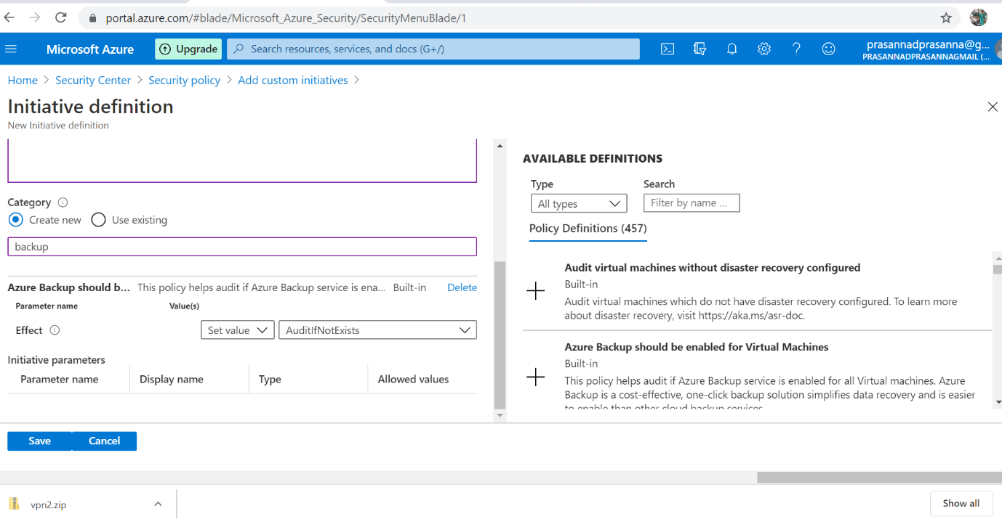

This is the created created security policy

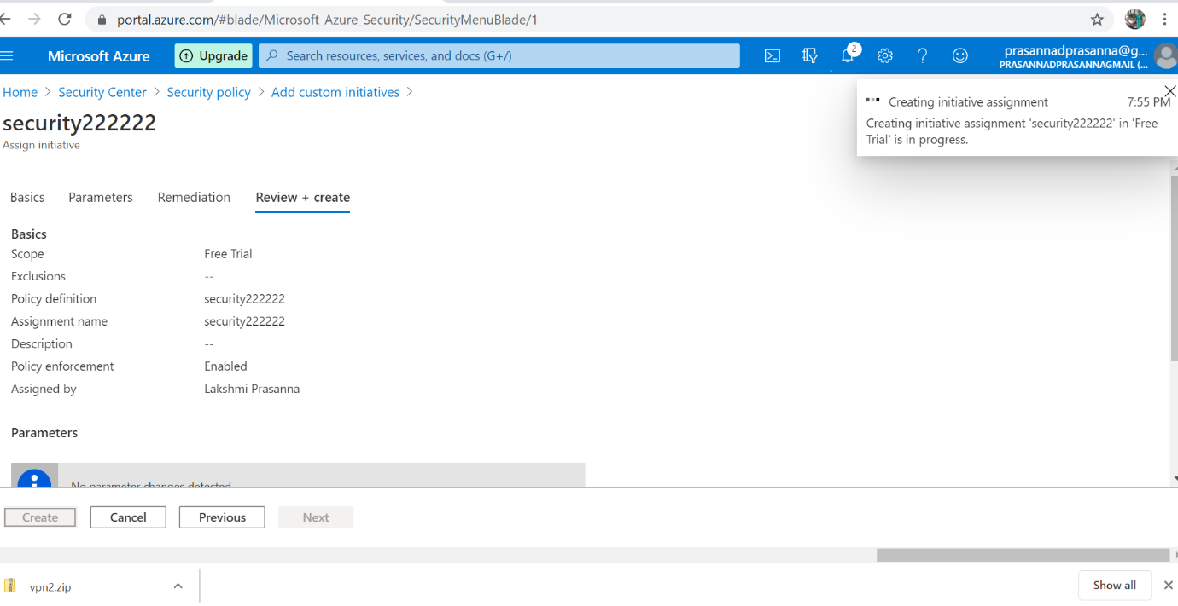

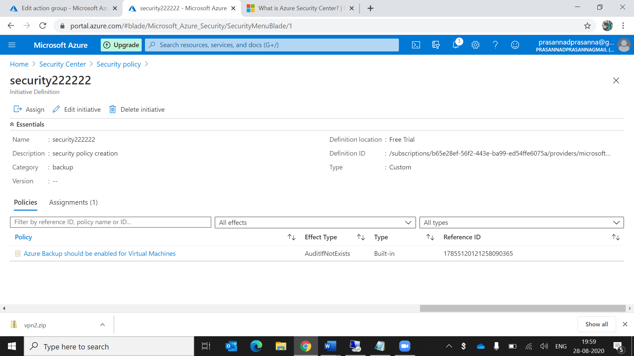

7.create a SQL server with database installed in the elastic pool

(In the search )sql servers and create the sql server

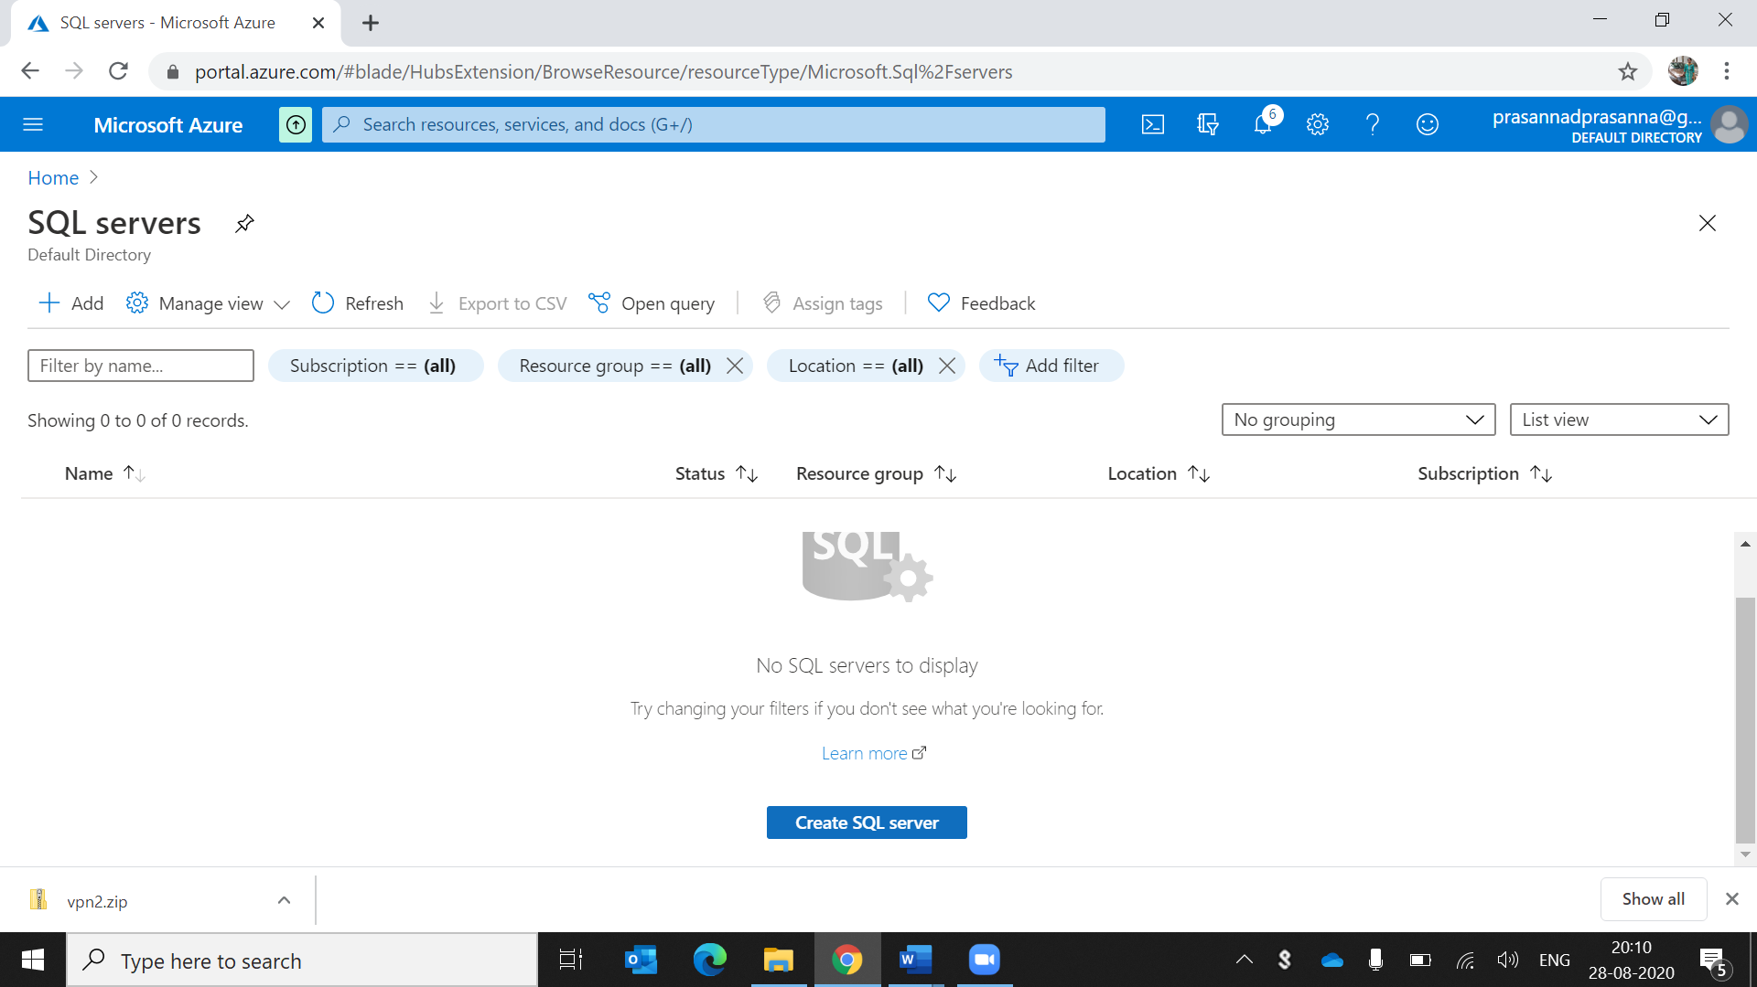

After creation this is the page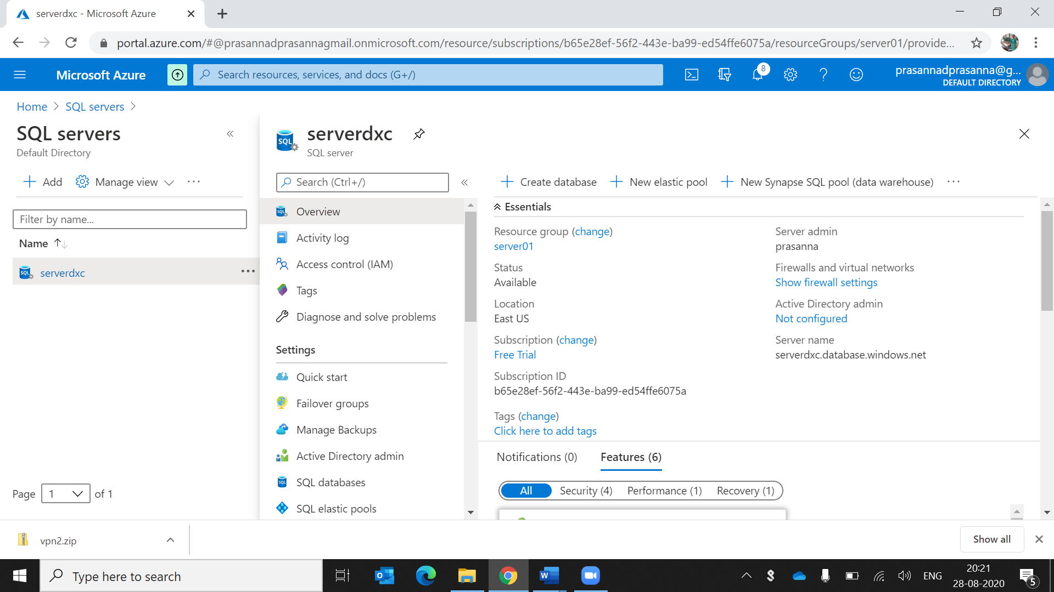

Create the sql database

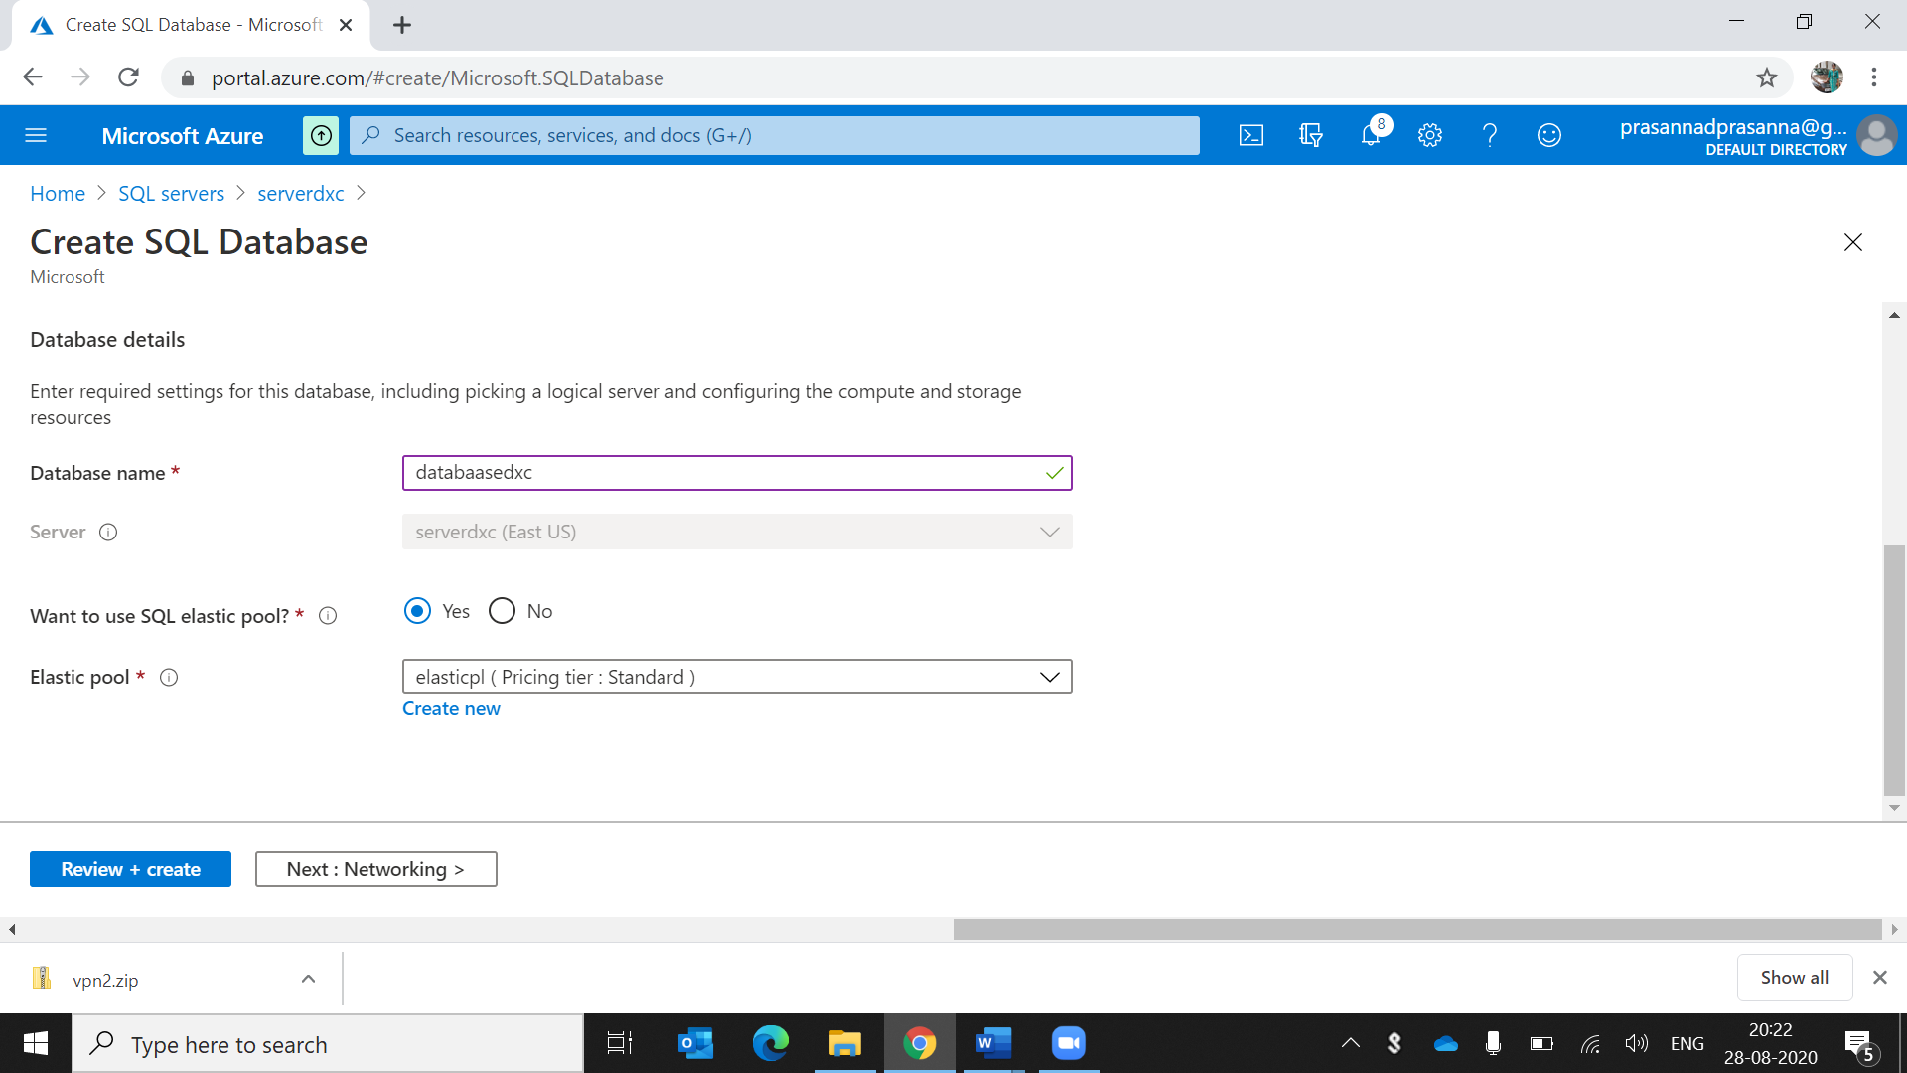

In that they ask the elastic pool details give that details 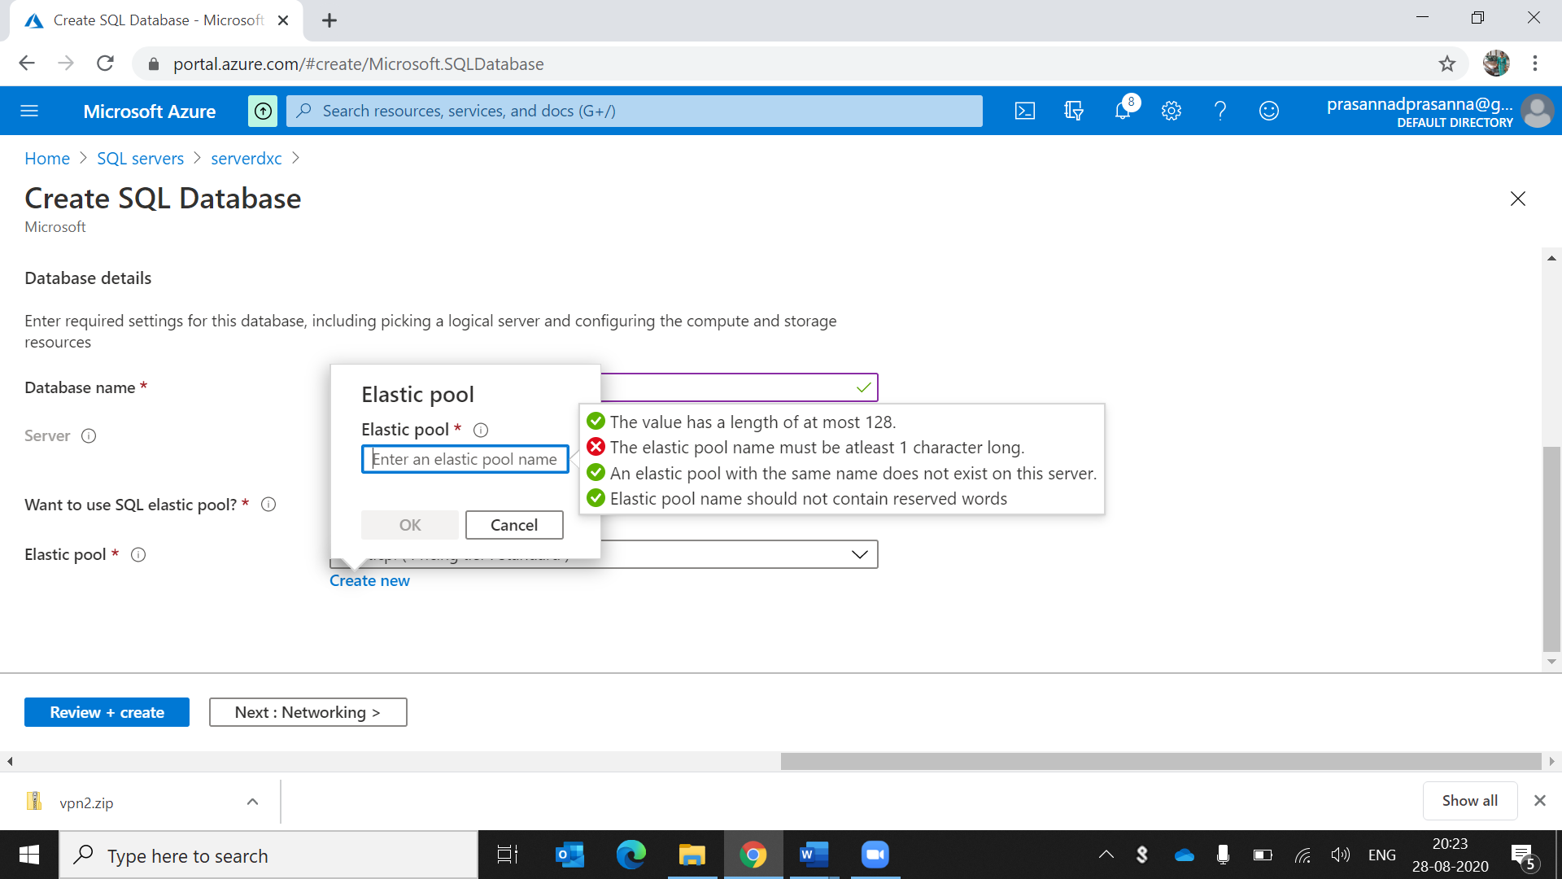

This is the created database

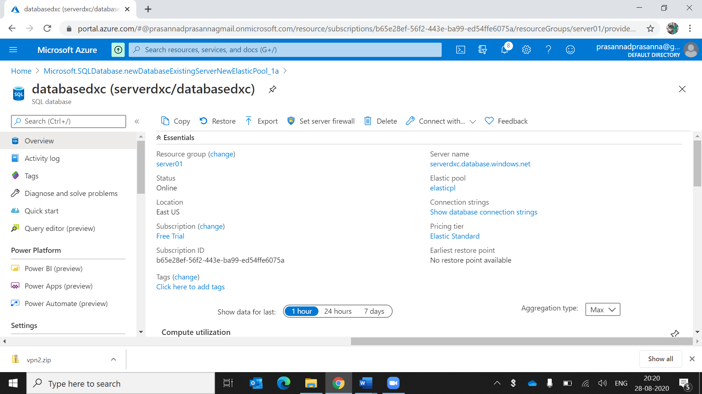

The elastic pool is created.